# Some assembly details for OpenSampler V5

The details provided here are meant to give an idea of how an AutoSampler can be constructed. This is by no means meant as a definitive guide or an easy step by step manual.

Knowledge of engineering, electronics and software will be needed to actually assemble your own OpenSampler.

No further personal support will be provided (unless you have an extremely short and detailed question).

I can sell the custom CNC parts (aluminum and plastic) needed for construction of an OpenSampler V5. But no additional support will be given! Email [info@openautosampler.com](mailto:info@openautosampler.com) for details.

Good luck and share your work too!

Frank

# C:\Users\Frank2014\AppData\Local\Microsoft\Windows\INetCache\Content.Word\OpenSamplerV4.jpg

Prototype of OpenSamplerV5 attached to an isotopic CO2 gas analyzer.

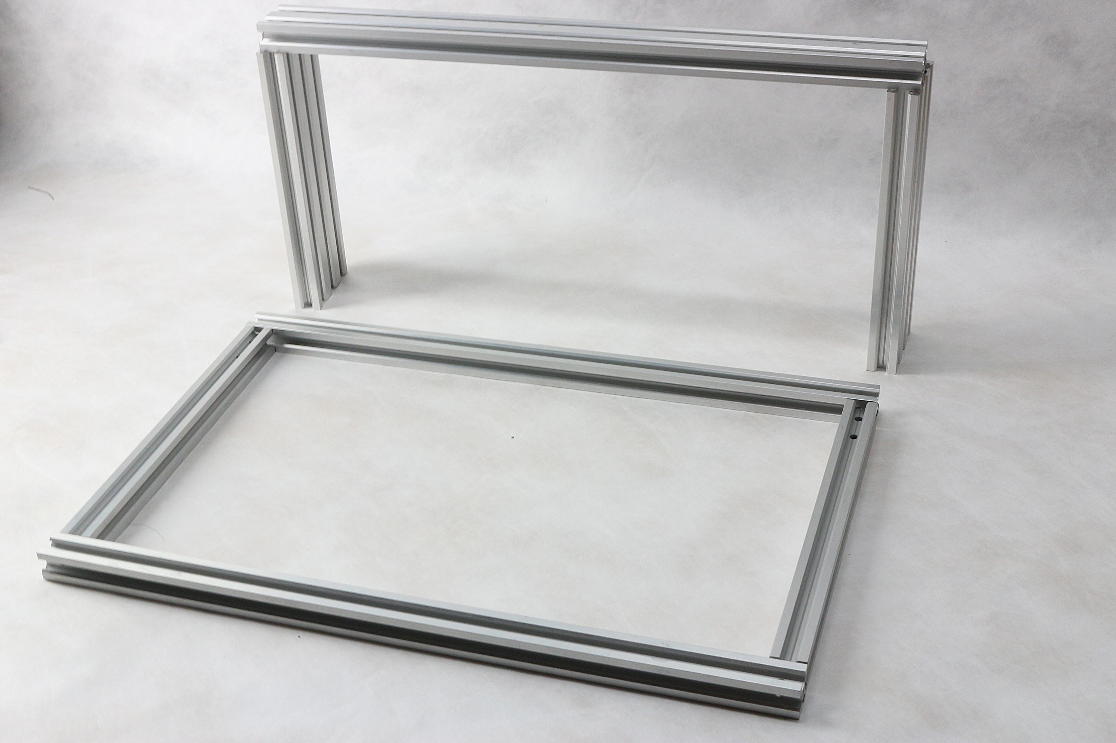

Frame parts, note the 5.5mm holes drilled to tighten connections.

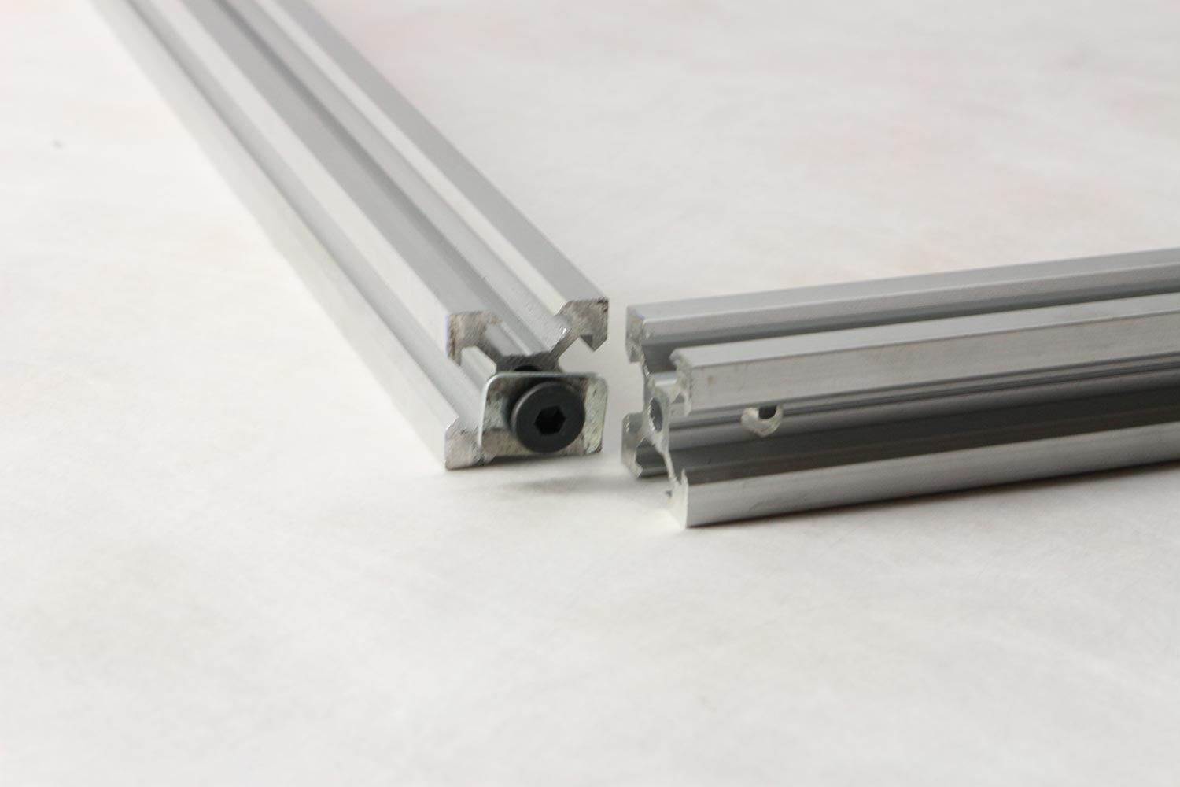

Detail of straight angle connection, 10mm ultra low profile hex screw with square washer and hole in connecting profile.

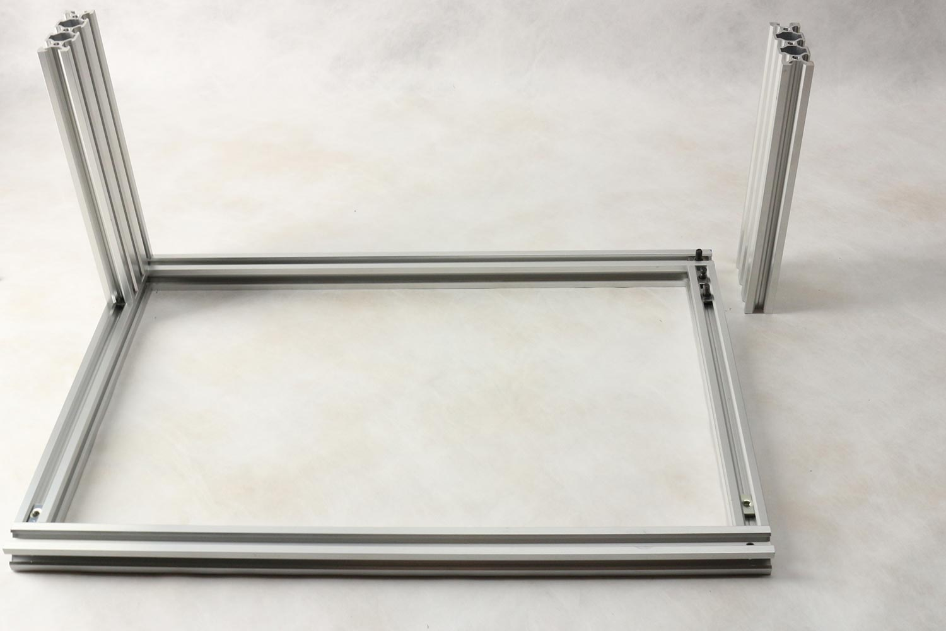

Frame with pre-inserted t-nuts for attachment of base plate and vertical frame.

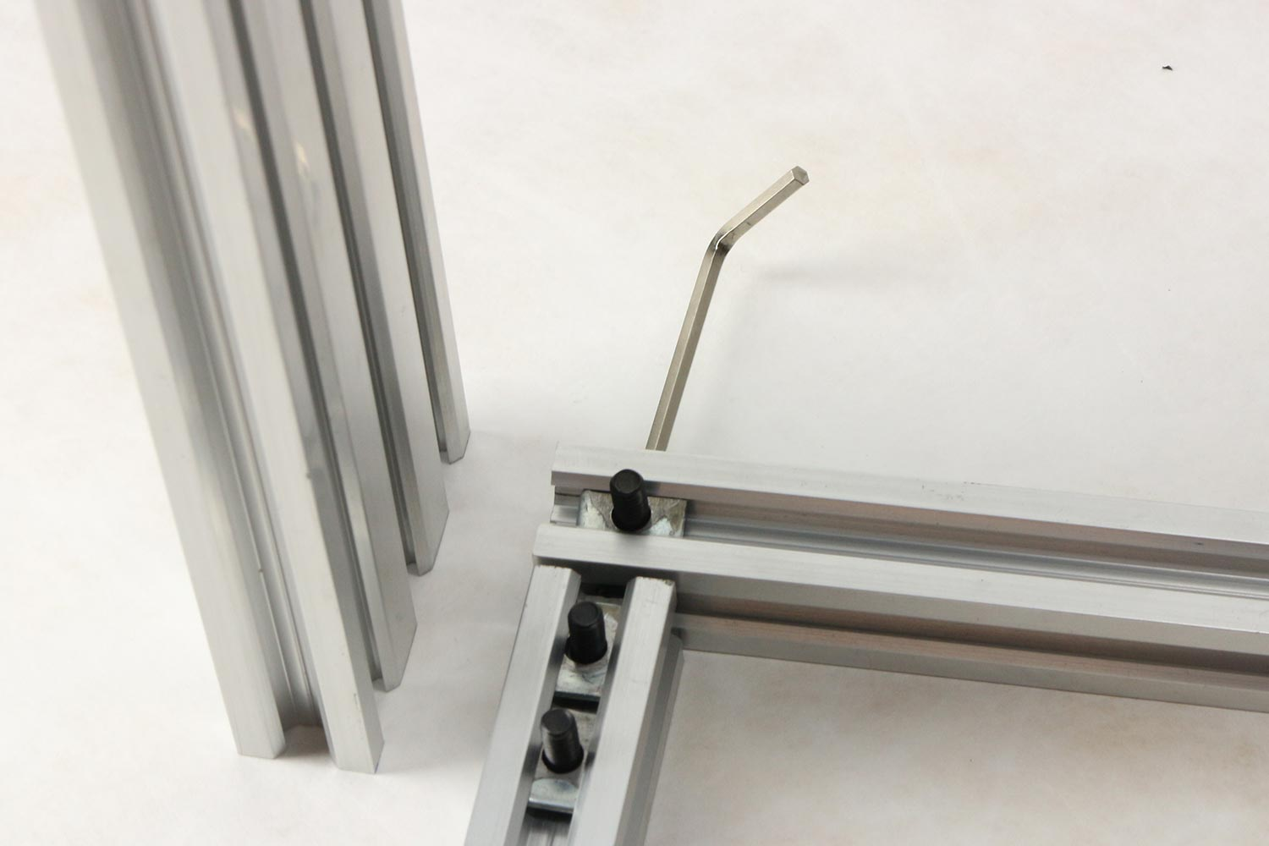

Detail of connection between bottom frame and vertical frame, 4 sets of screw and square washers (1 hidden with hex key inserted)

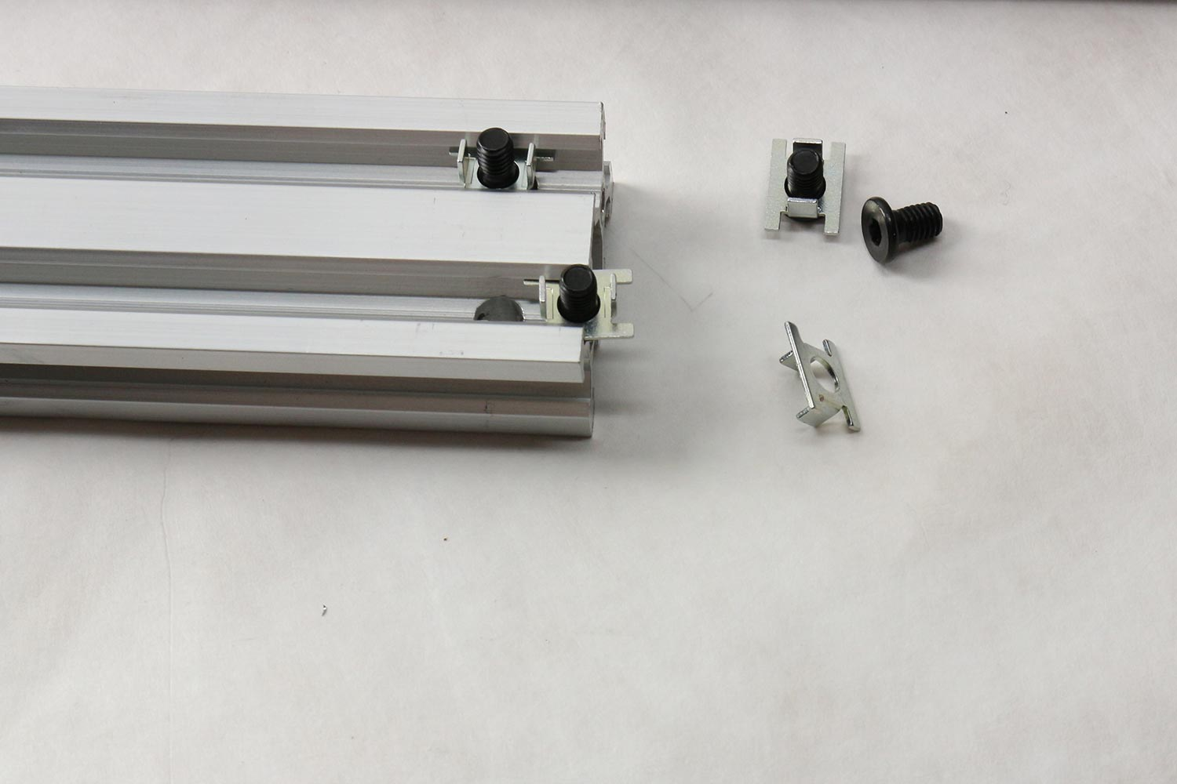

Top horizontal frame (x-axis guide) with details of fasteners.

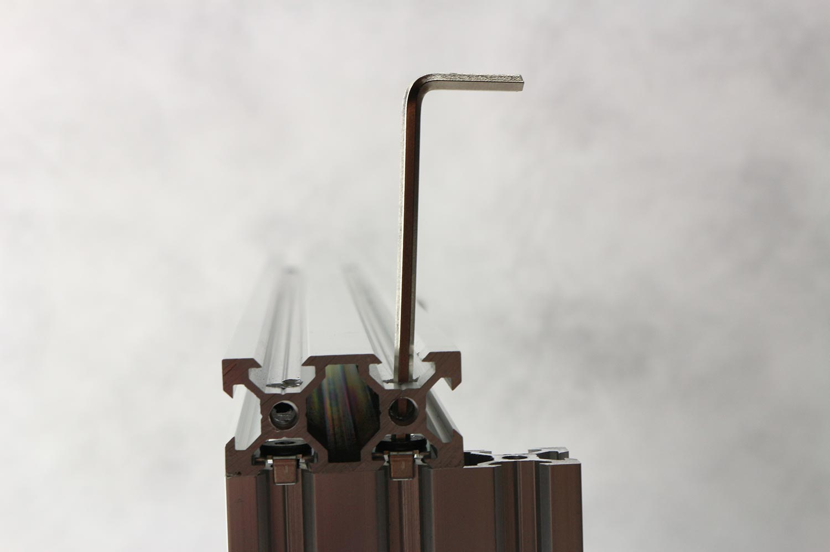

Fastening of top horizontal frame to vertical frame.

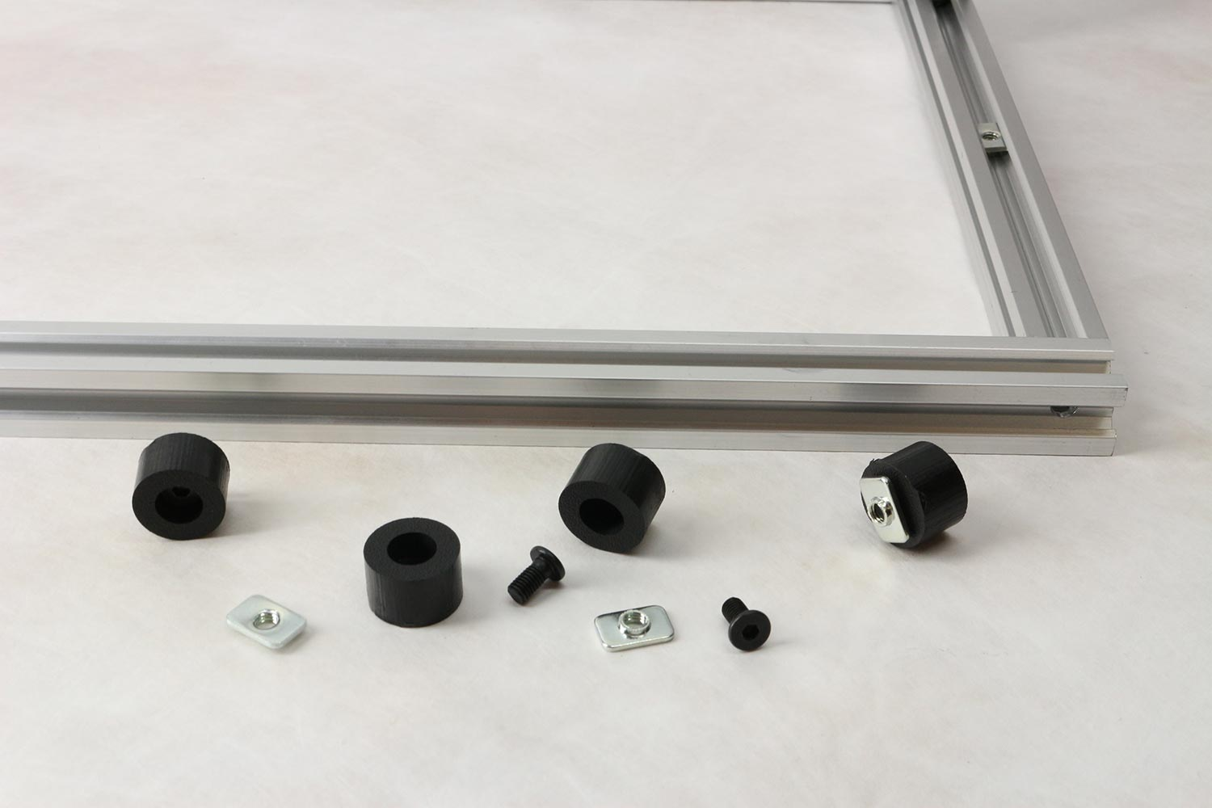

Parts for feet for under frame.

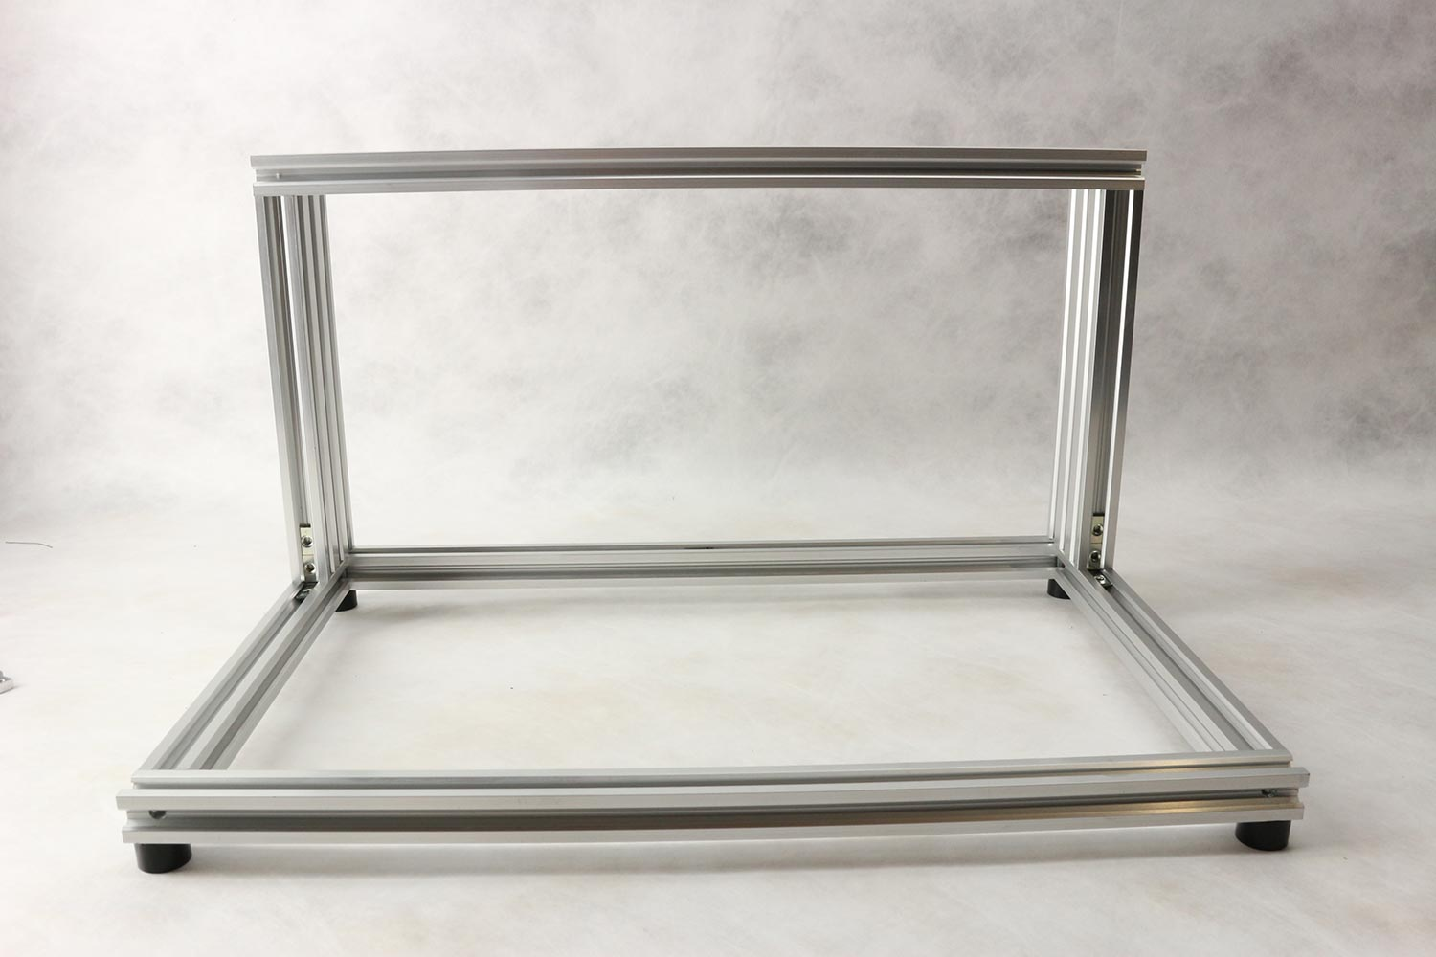

Feet mounted under completed frame.

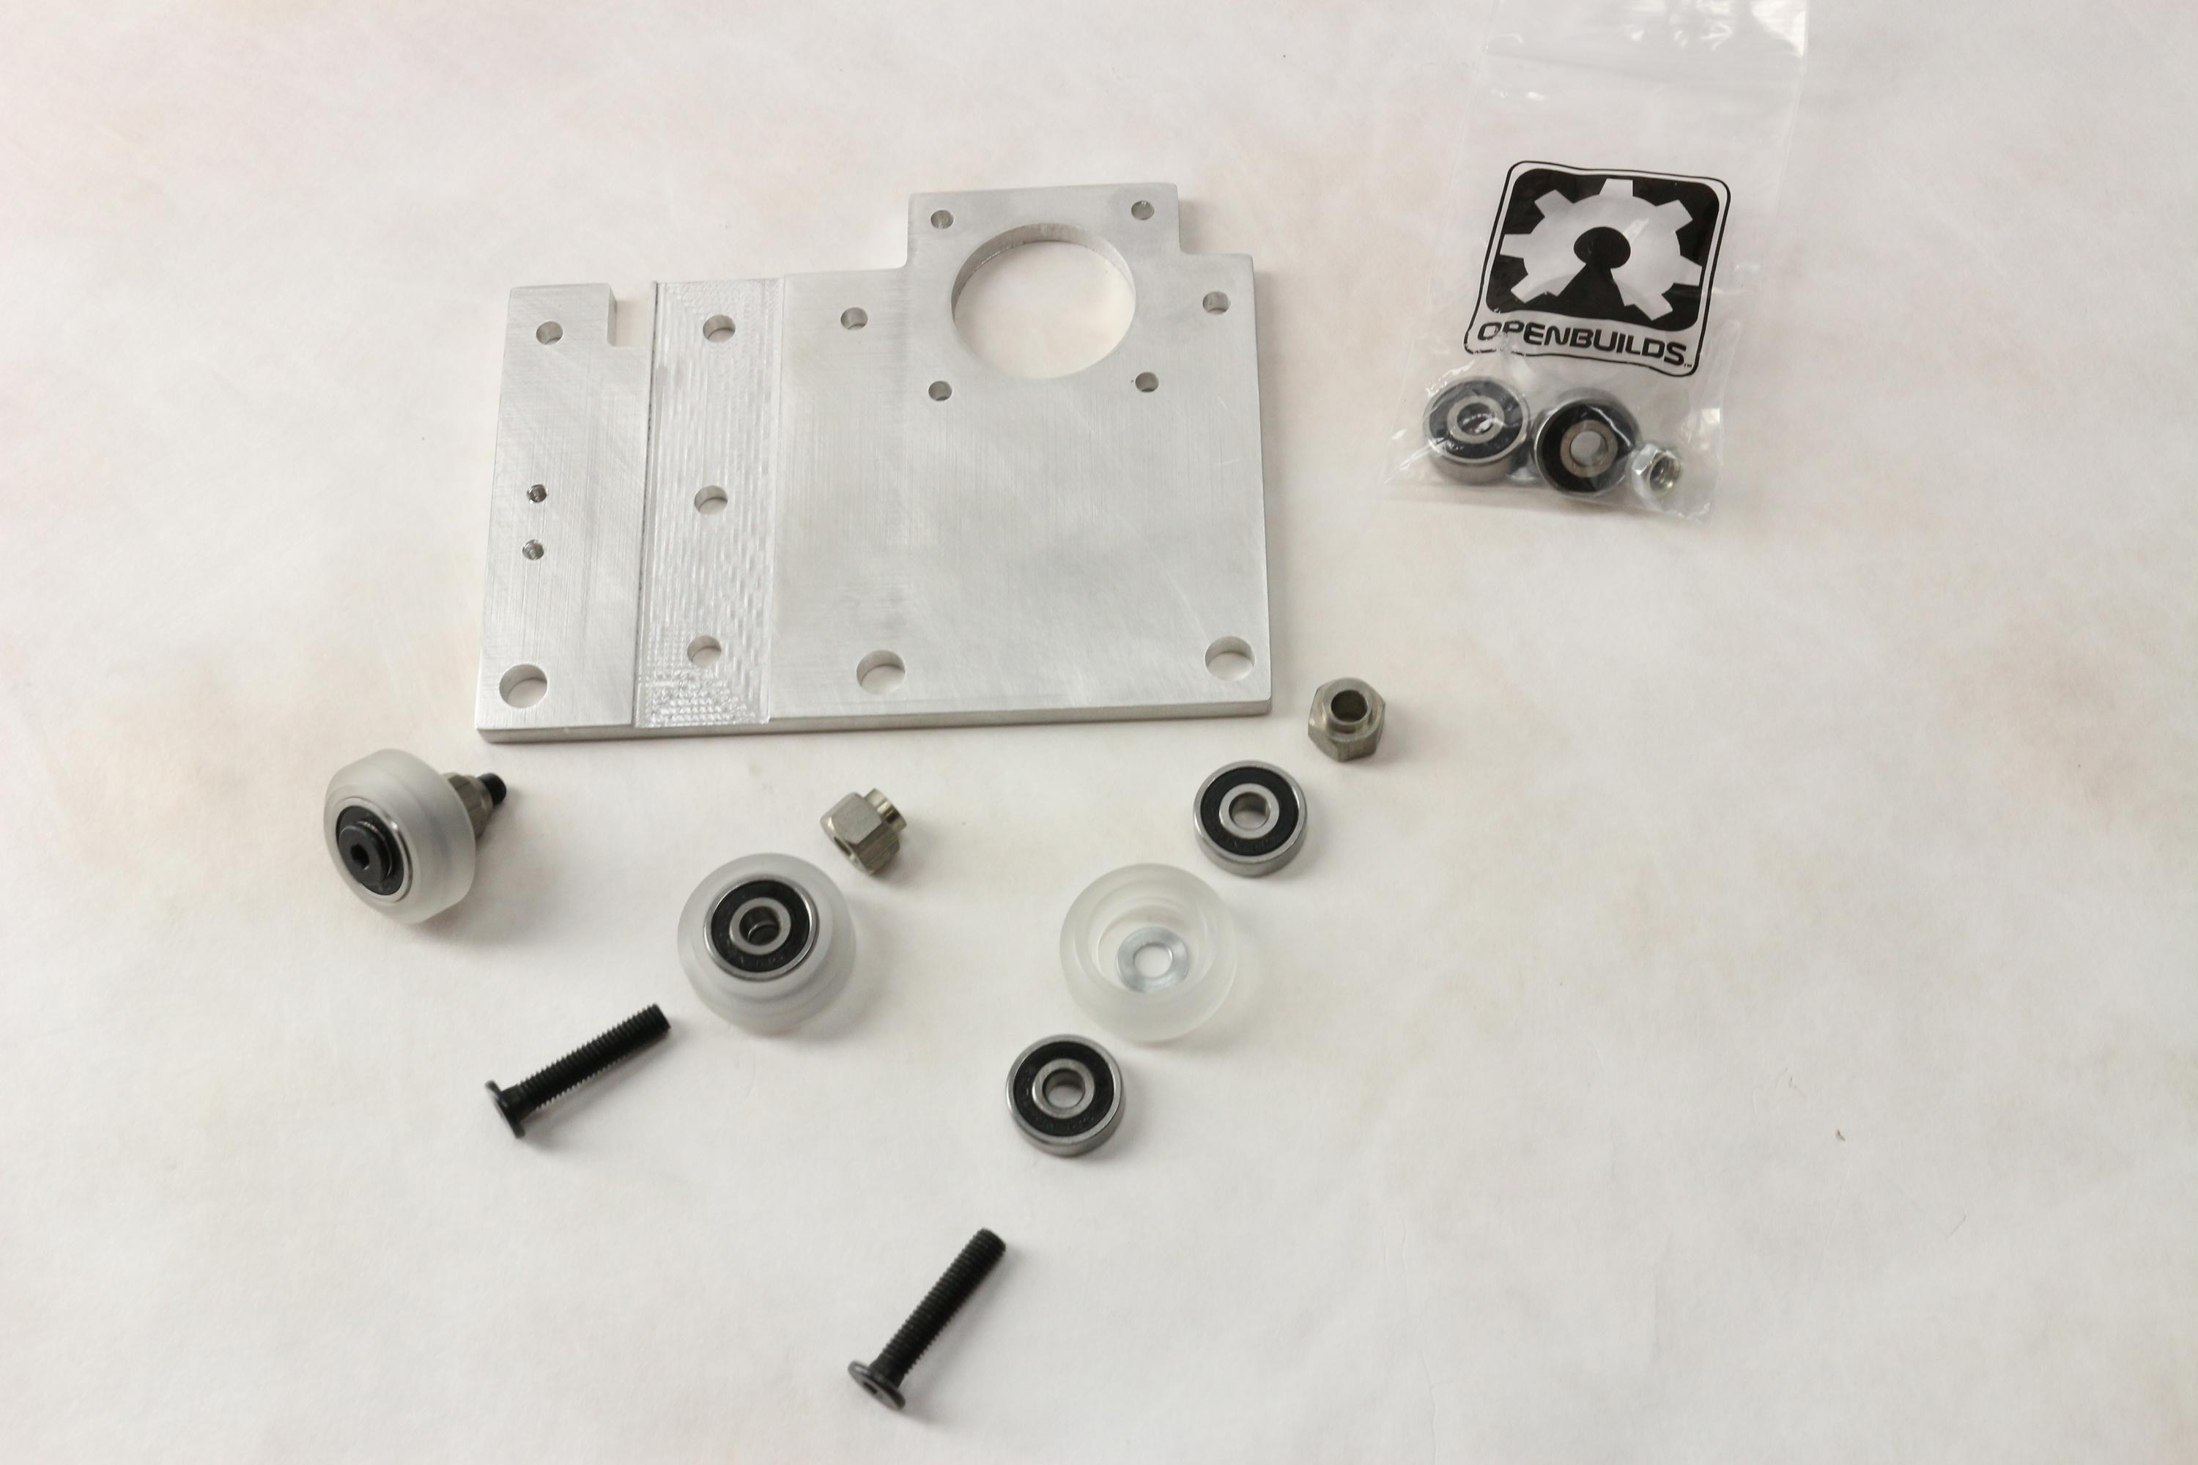

Parts for x-axis cart, total of 6 wheels are required

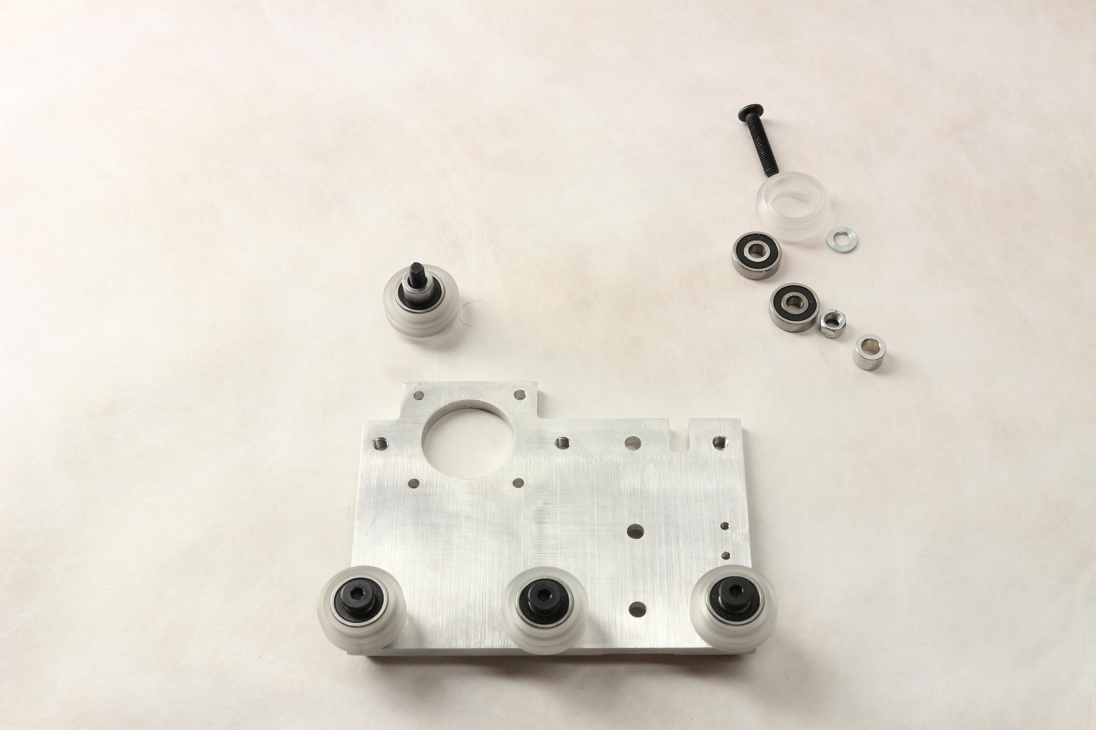

Detail of mounting of wheels to x-axis cart.

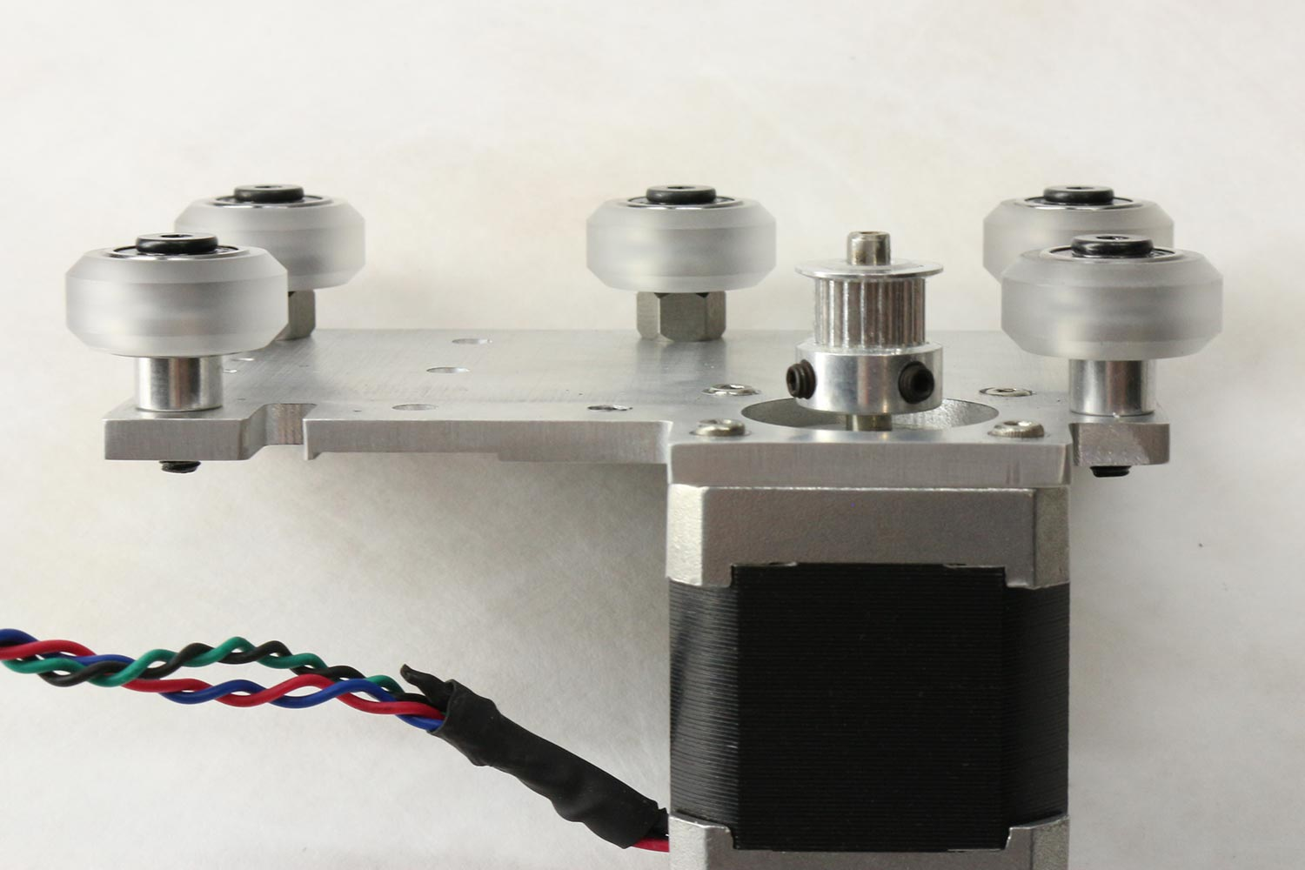

Only 5 wheels will be mounted for now, 6th will be added with cable-carrier. Screws for x-axis motor need to be counter sunk.

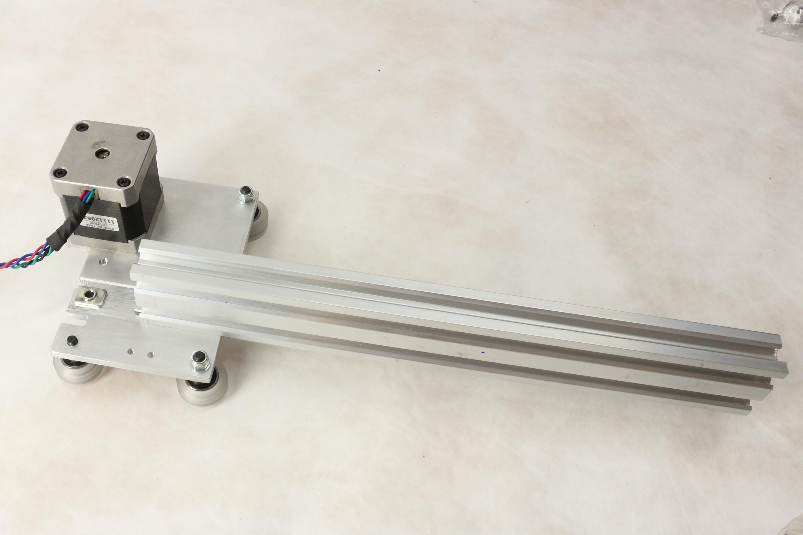

Attachment of y-guide to x-axis cart. The y-guide profile sits in pocket in x-cart to guarantee square.

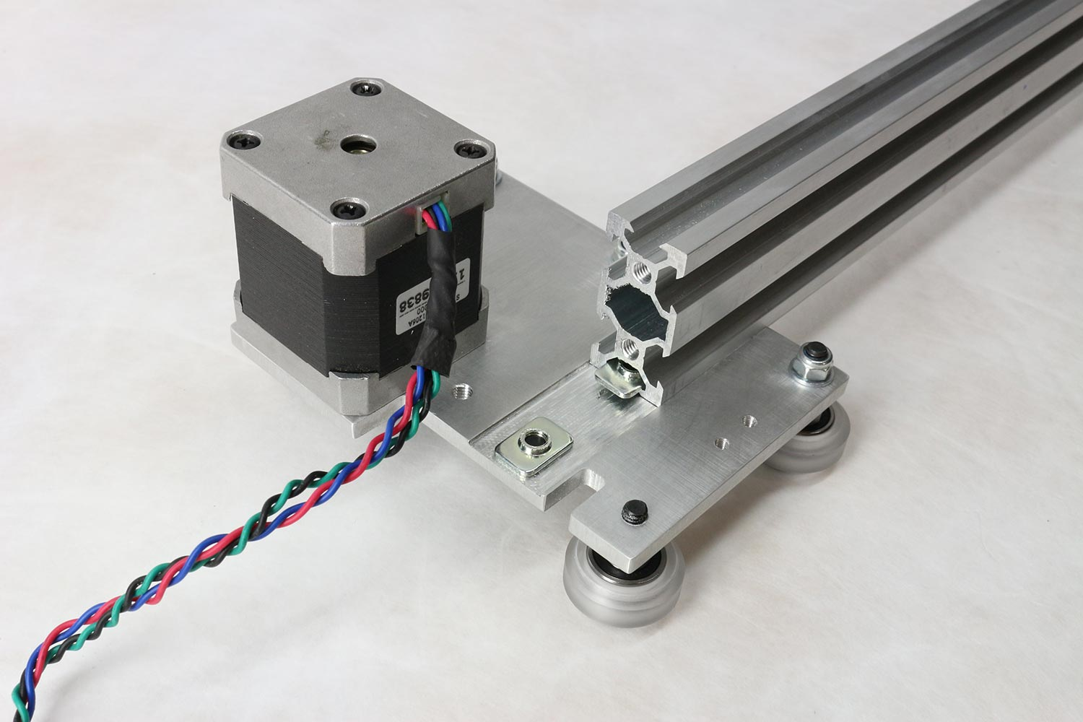

Attachment of y-guide to x-axis cart. The y-guide profile sits in pocket in x-cart to guarantee square.

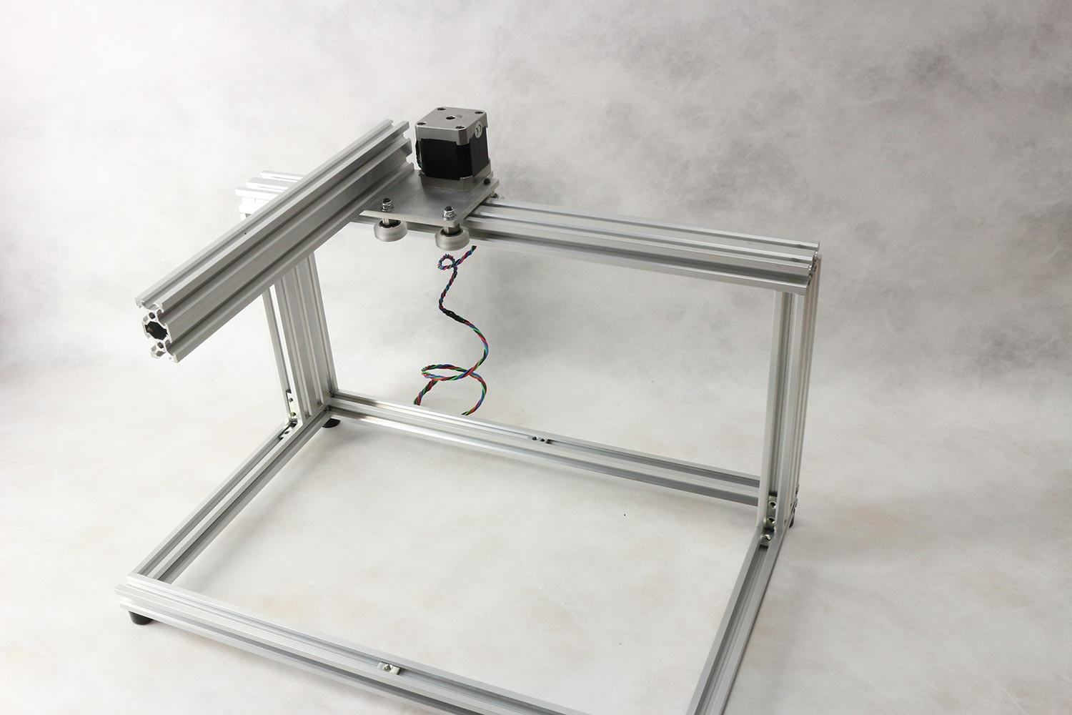

X-cart mounted on frame

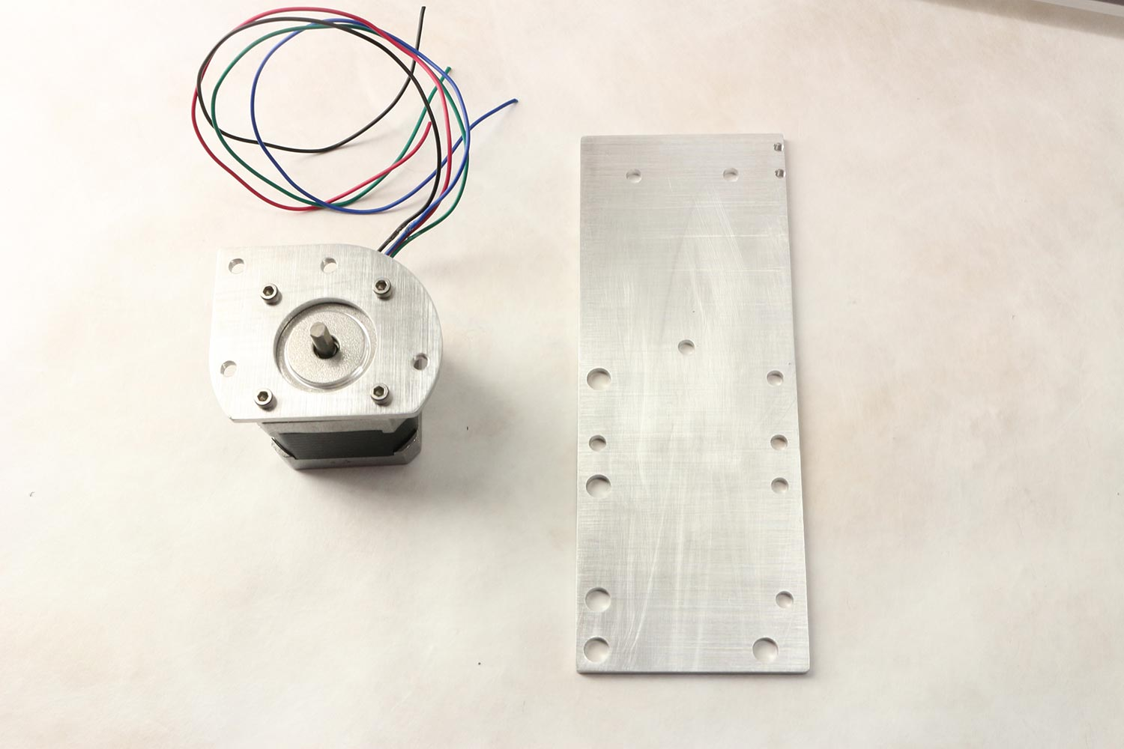

y-cart and y-motor-plate.

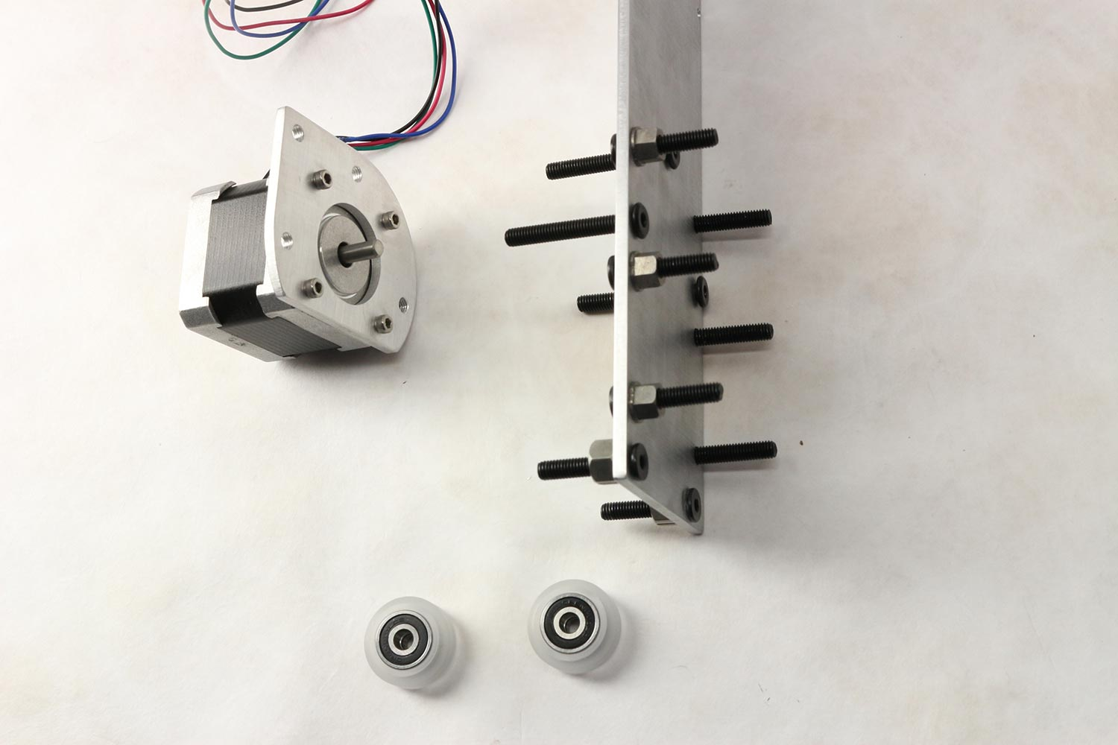

6 mini-wheels will be attached on right side for z-axis, 4 wheels will be mounted on left side for y-axis movement.

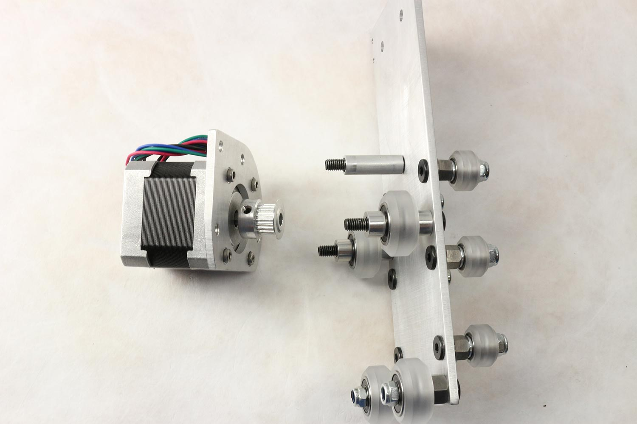

Wheels and spacers mounted on y-axis cart

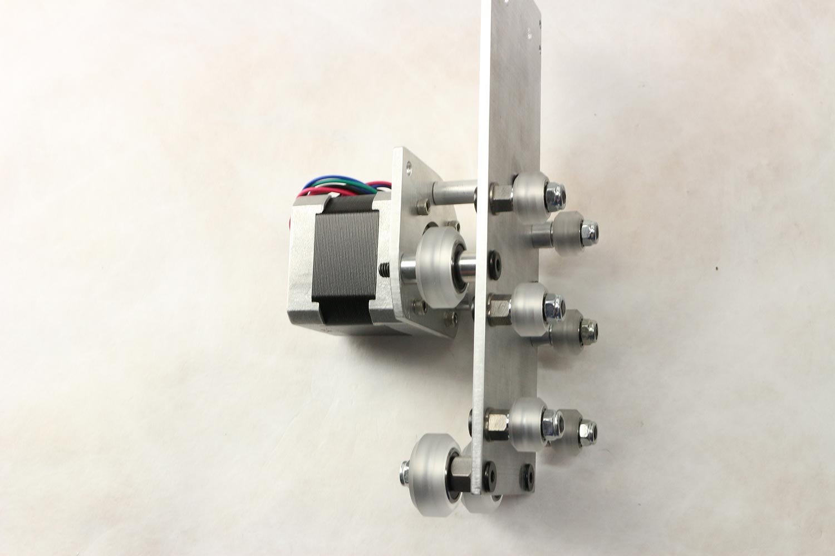

Wheels and spacers and y-motor mounted on y-axis cart

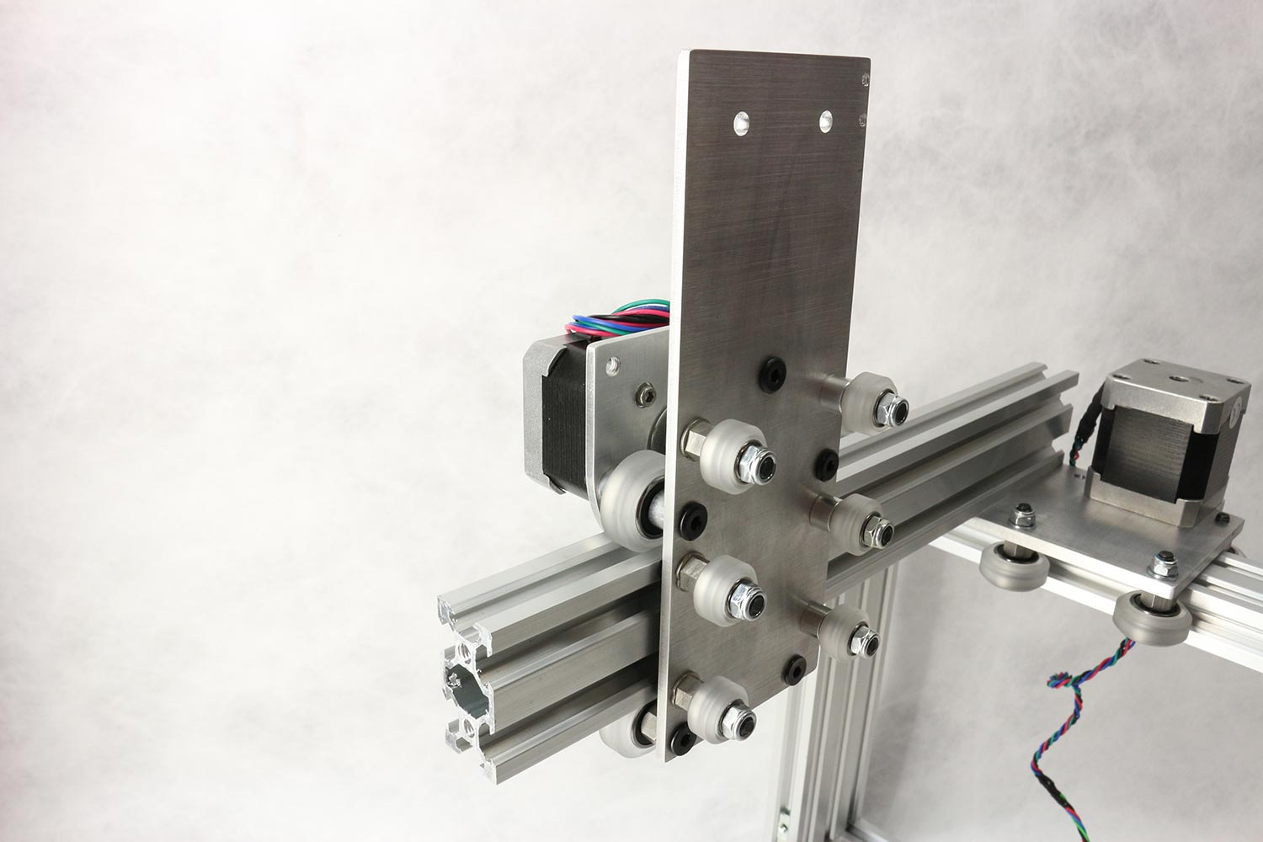

Y-cart mounted on y-guide/x-cart.

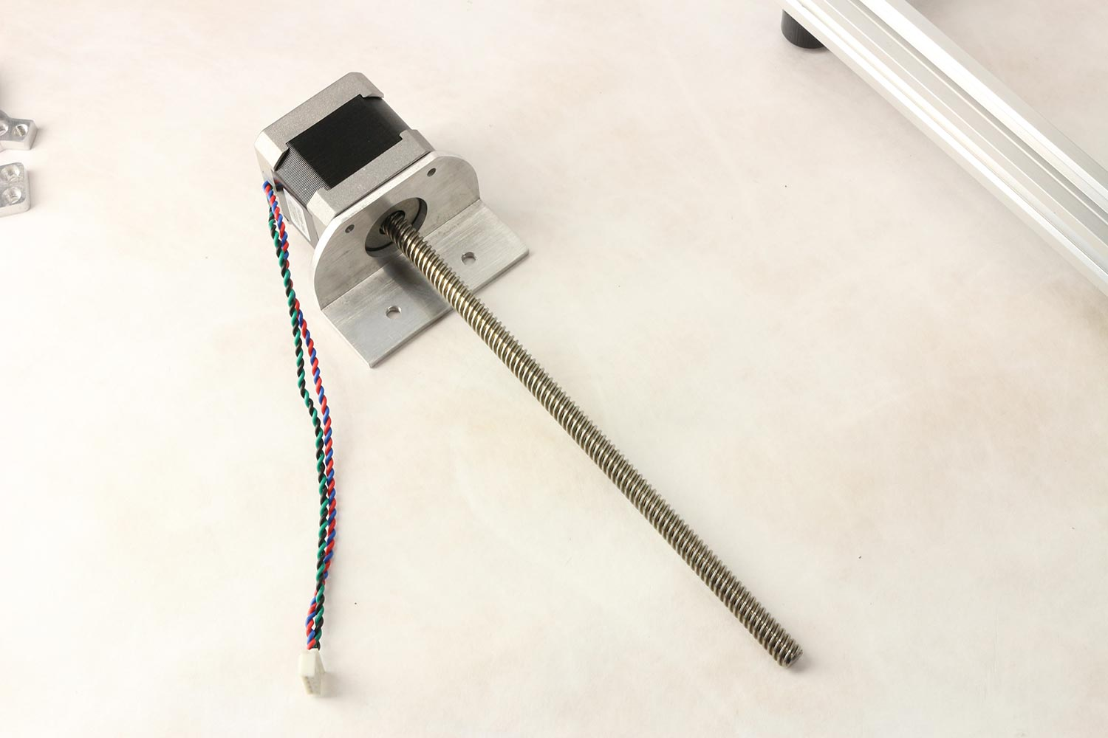

Z-motor on z-motor-mount.

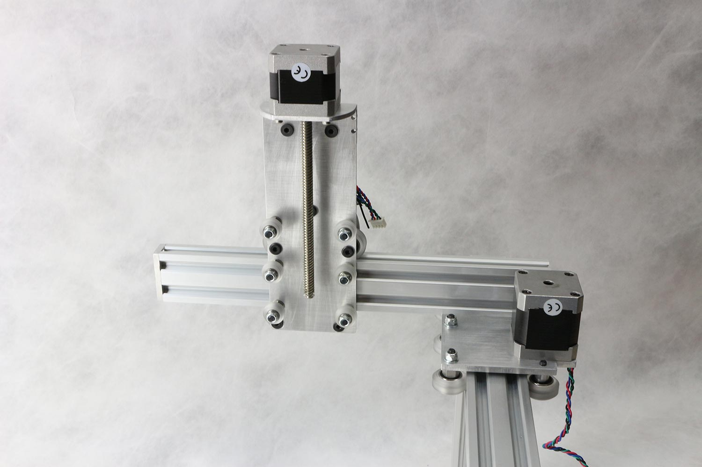

Z-motor-mount attached to y-cart.

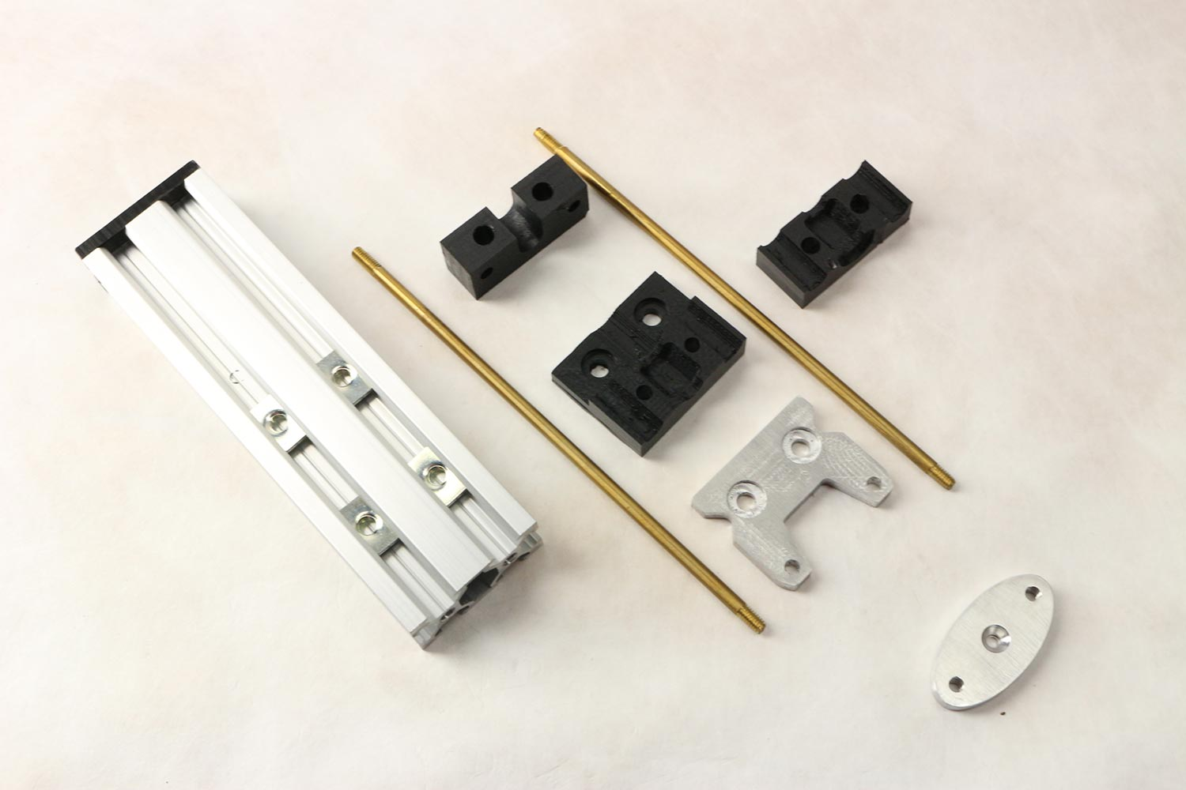

Z-profile and parts for needle attachment.

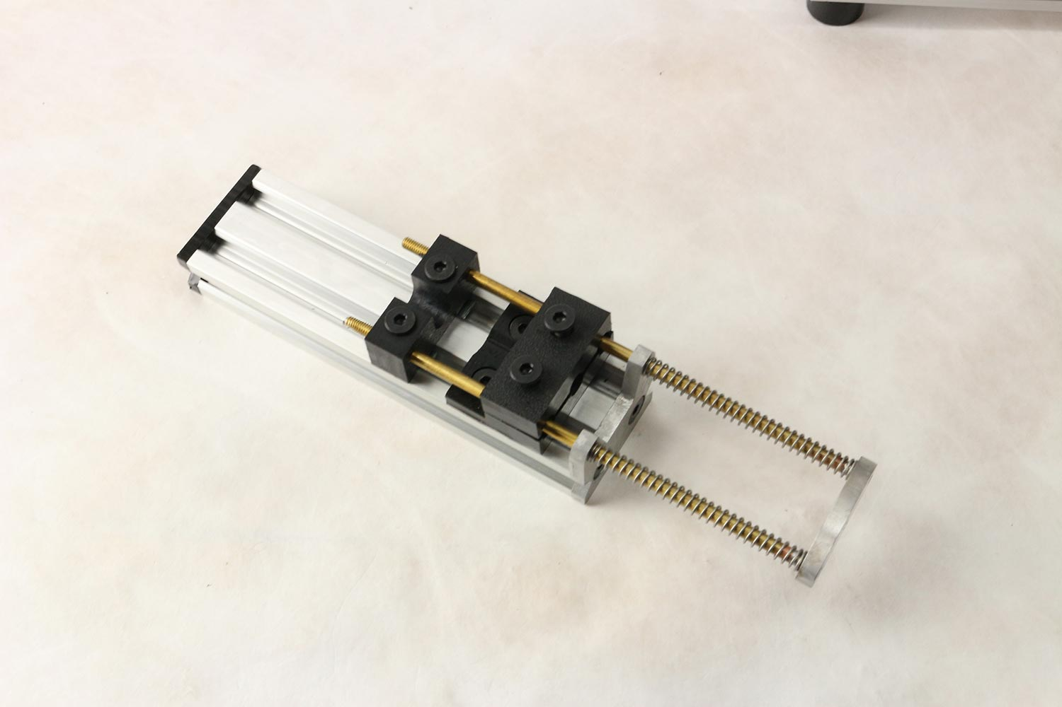

Completed z-axis assembly and needle mount

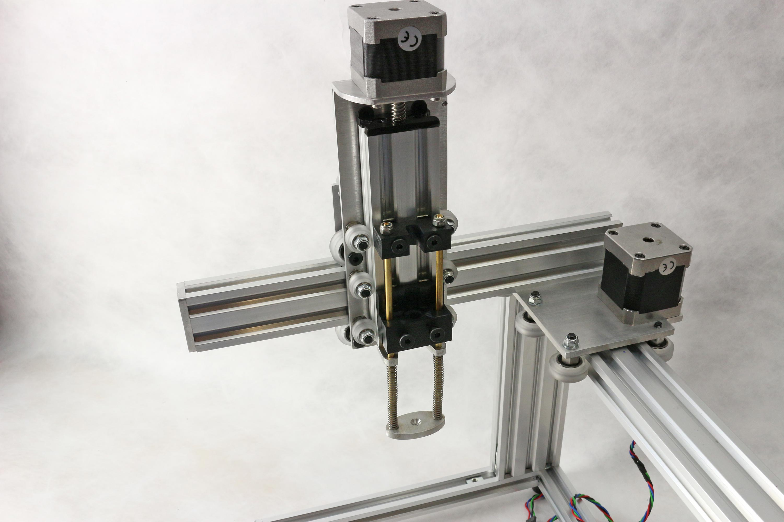

Z-axis mounted on y-cart.

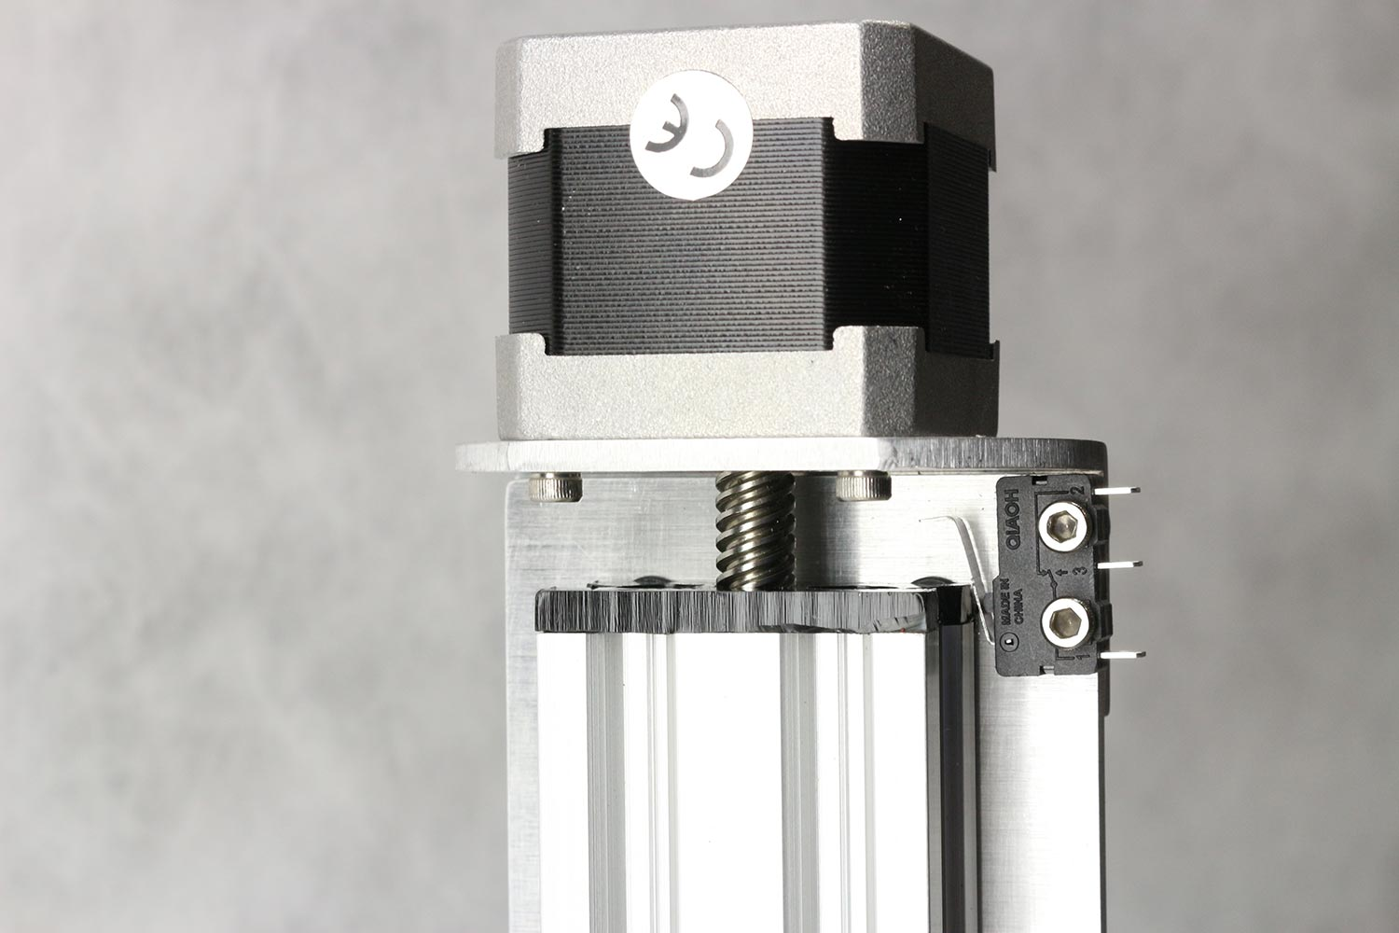

Z-endstop attached on y-cart

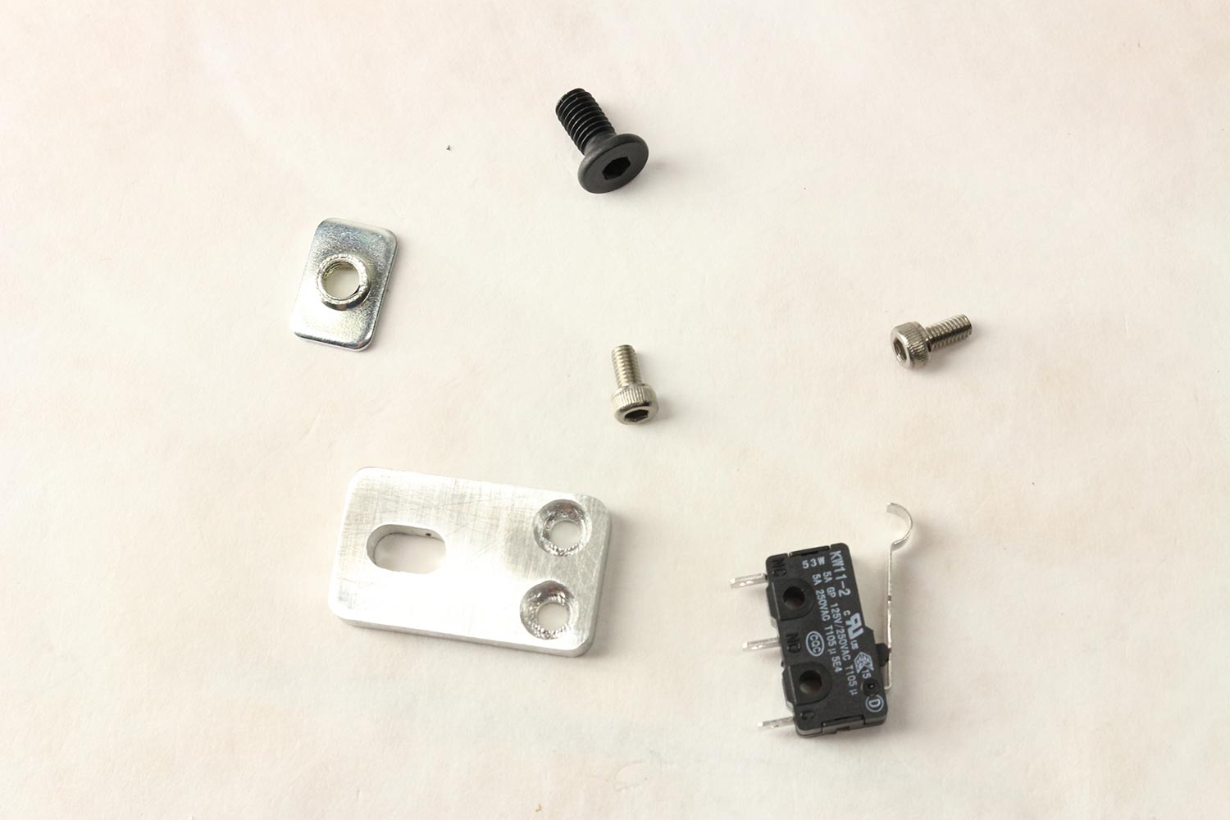

Parts for y-endstop.

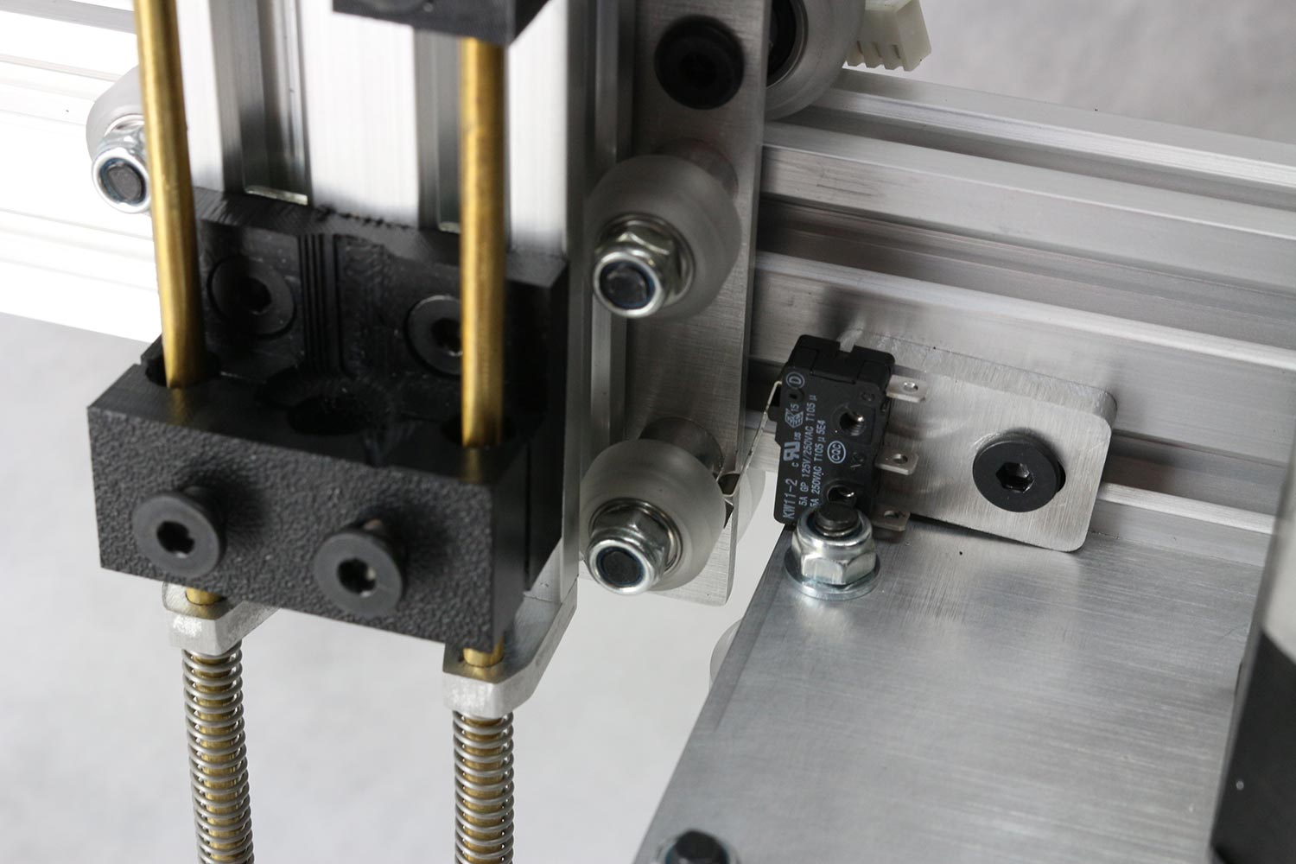

Y-endstop mounted on x-cart/y-guide

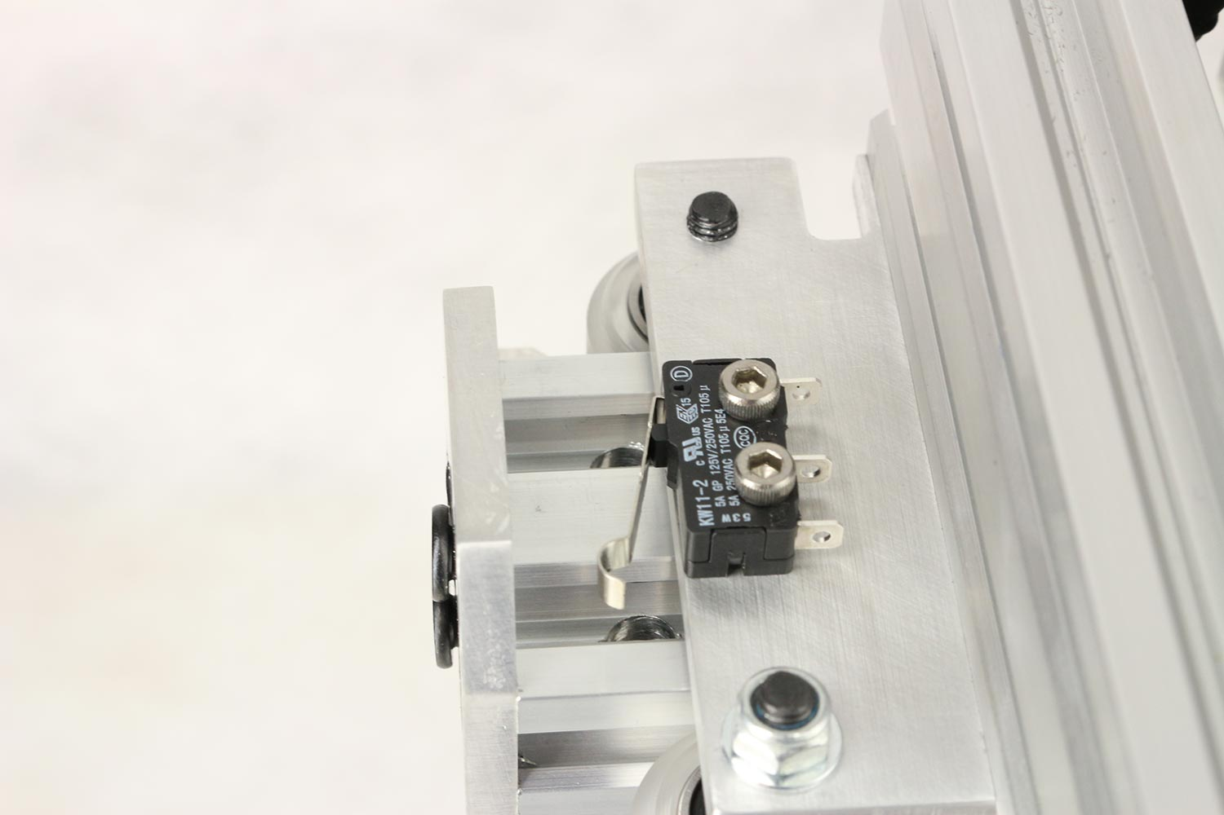

X-endstop mounted on x-cart

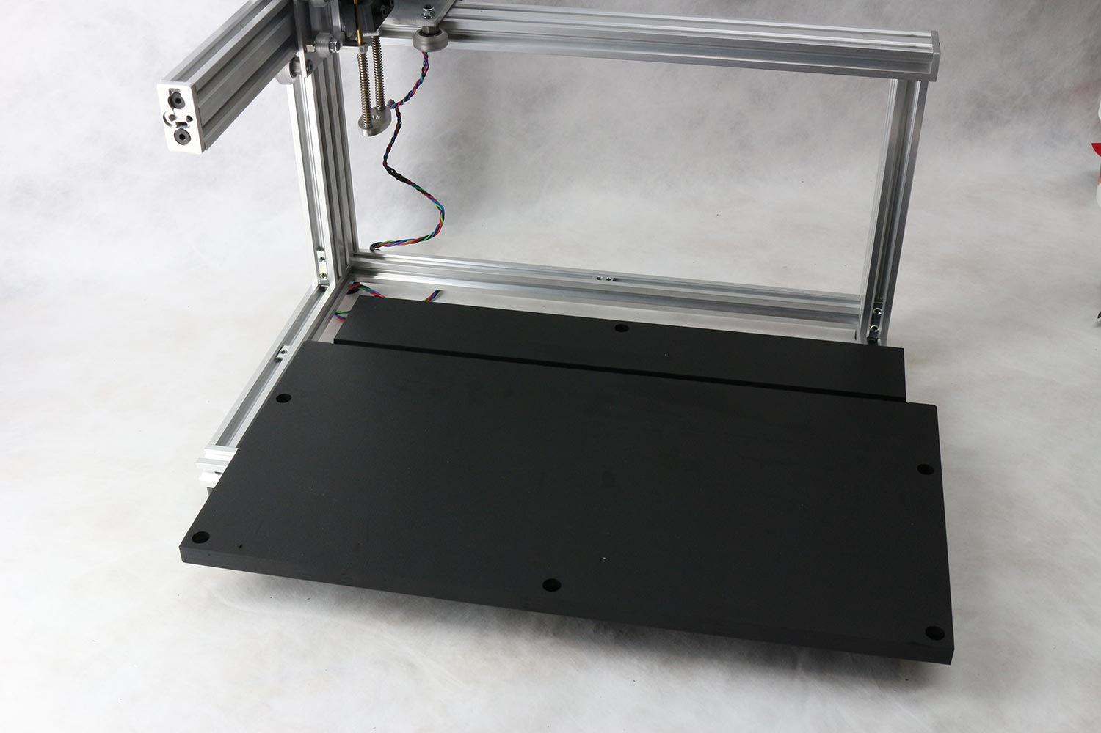

Base plate to be mounted on frame

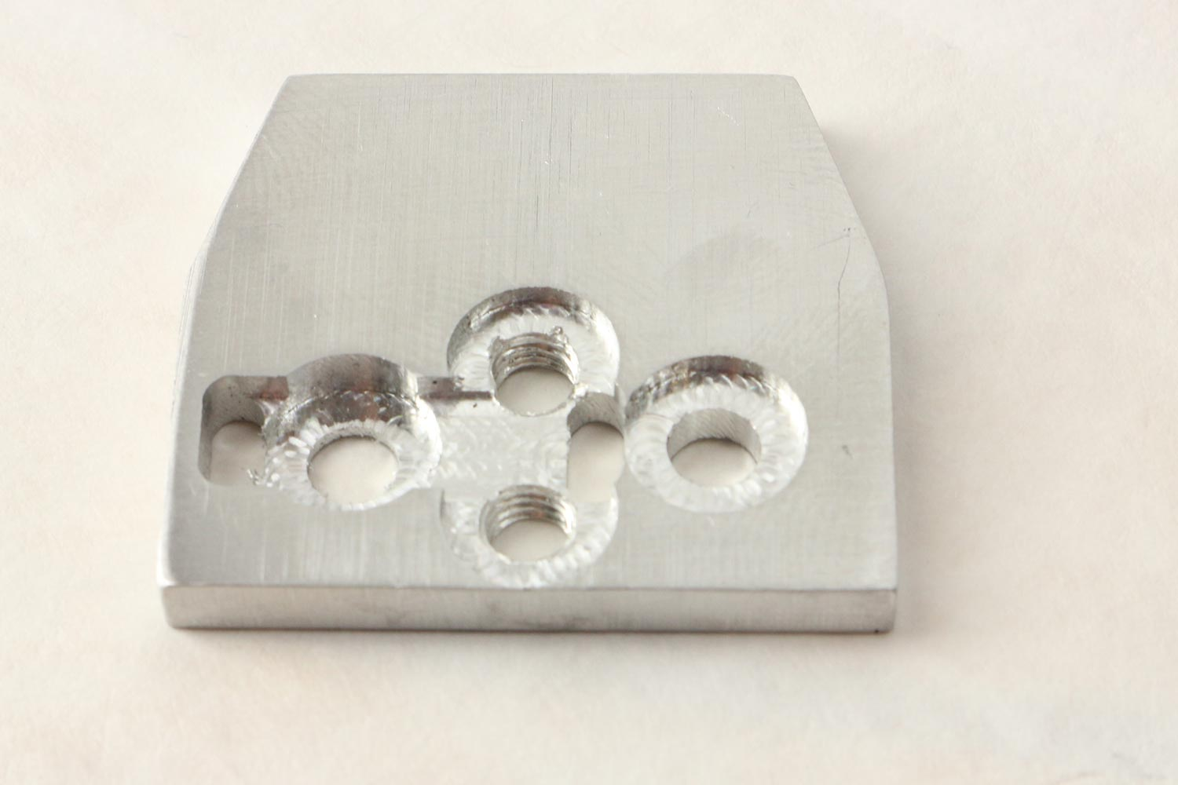

x-endstop-endplate is used to tighten x-belt and as plate that the x-endstop runs into.

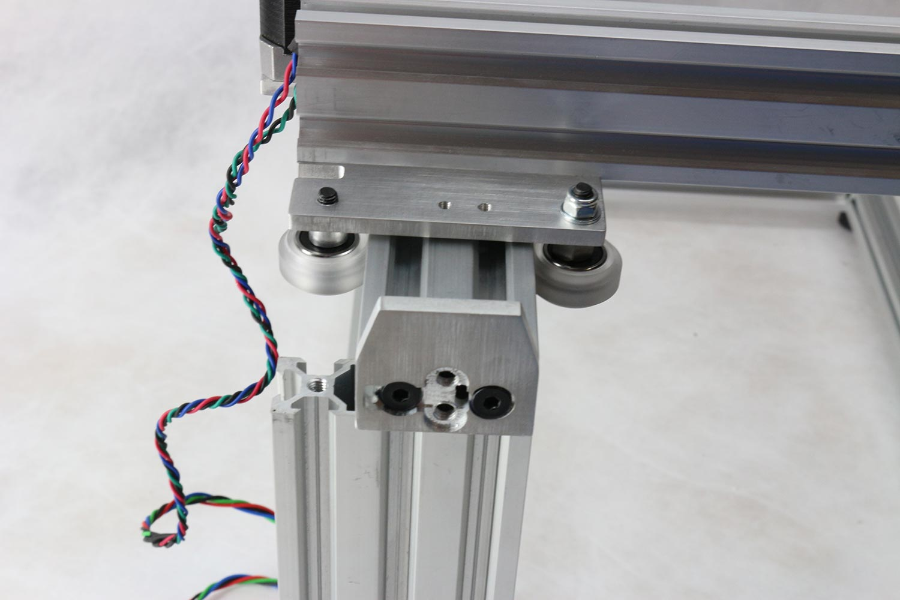

x-endstop-endplate is used to tighten x-belt and as plate that the x-endstop runs into mounted on frame.

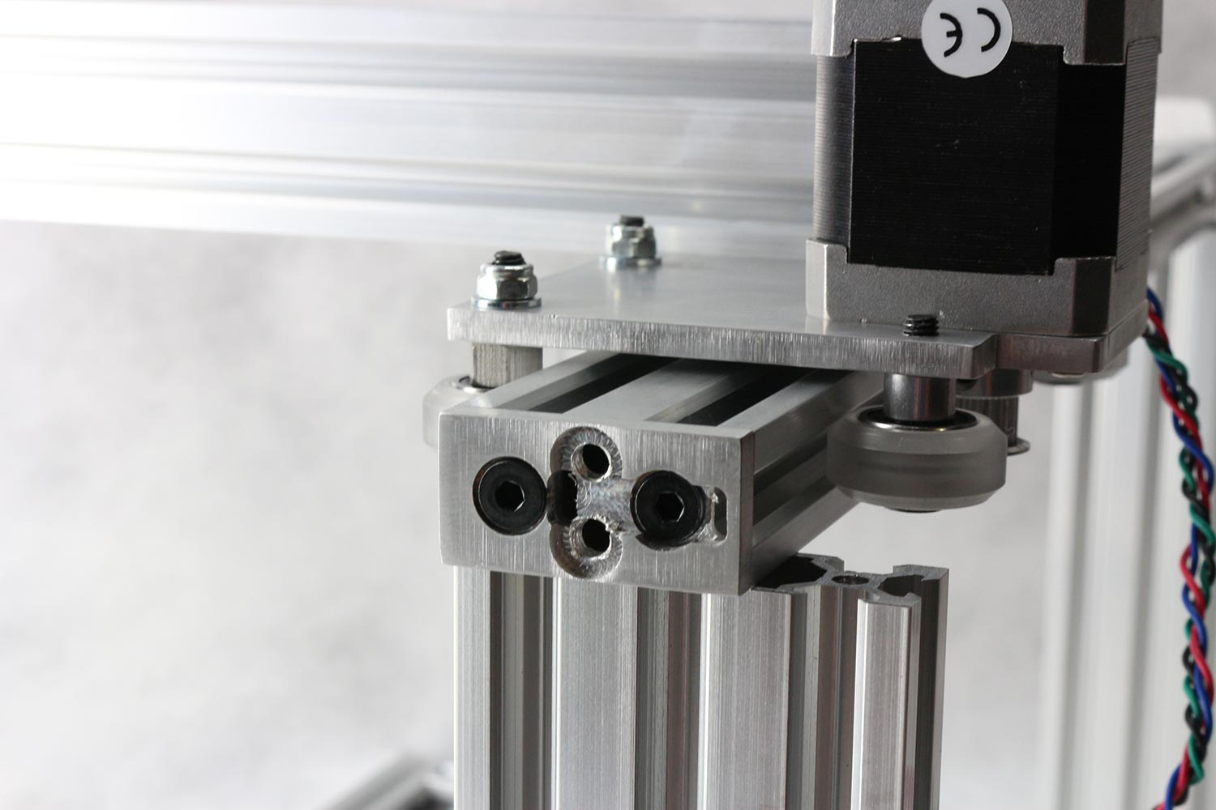

Opposite end of x-axis frame.

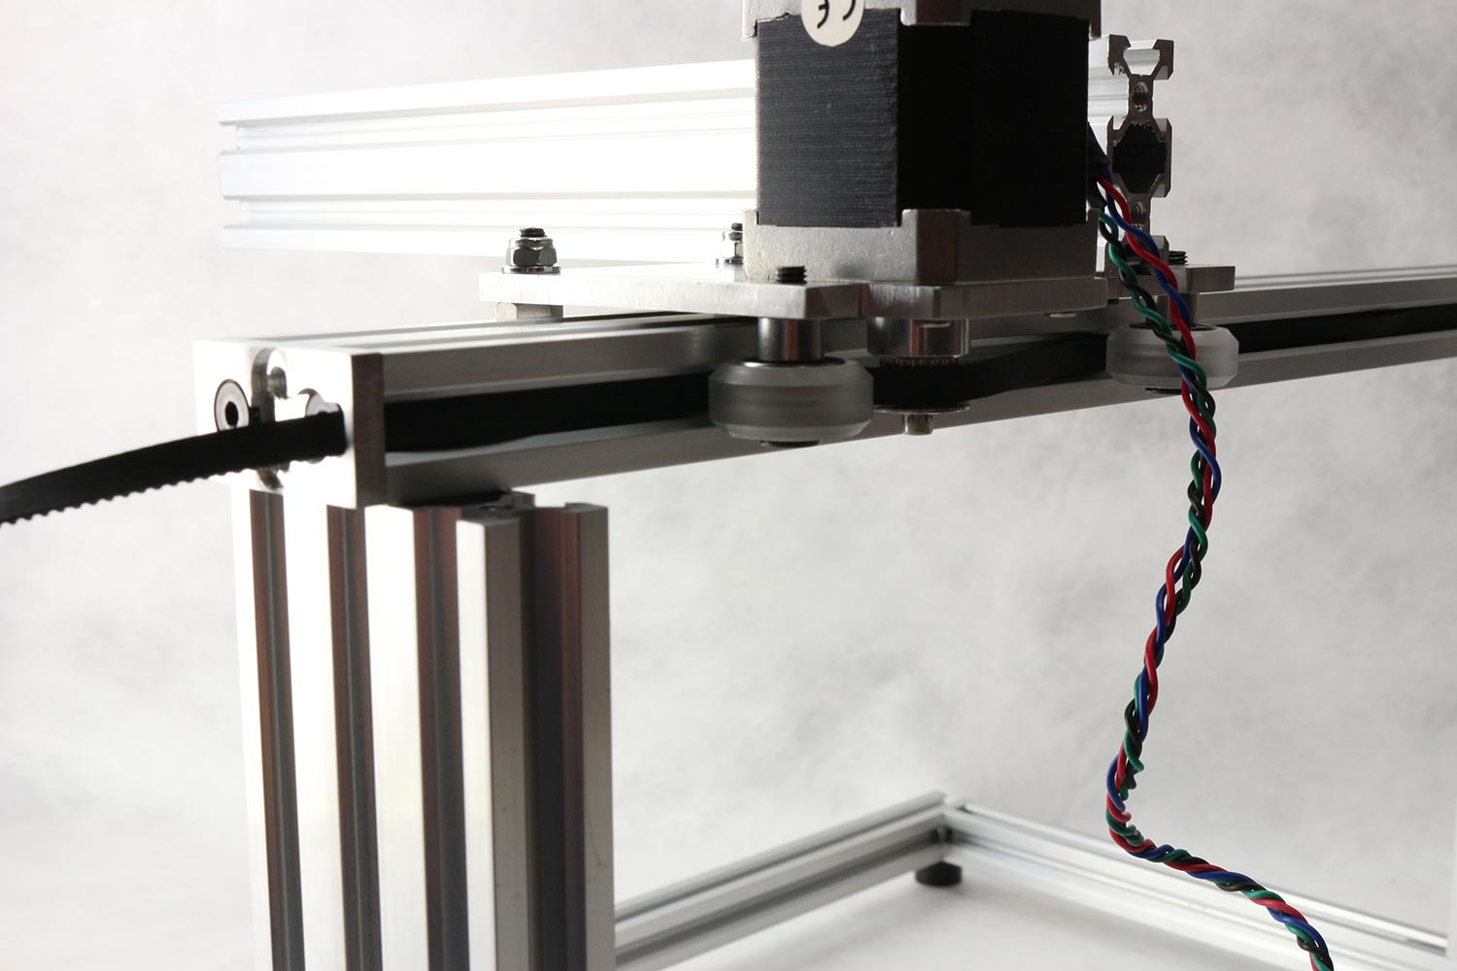

X-belt detail

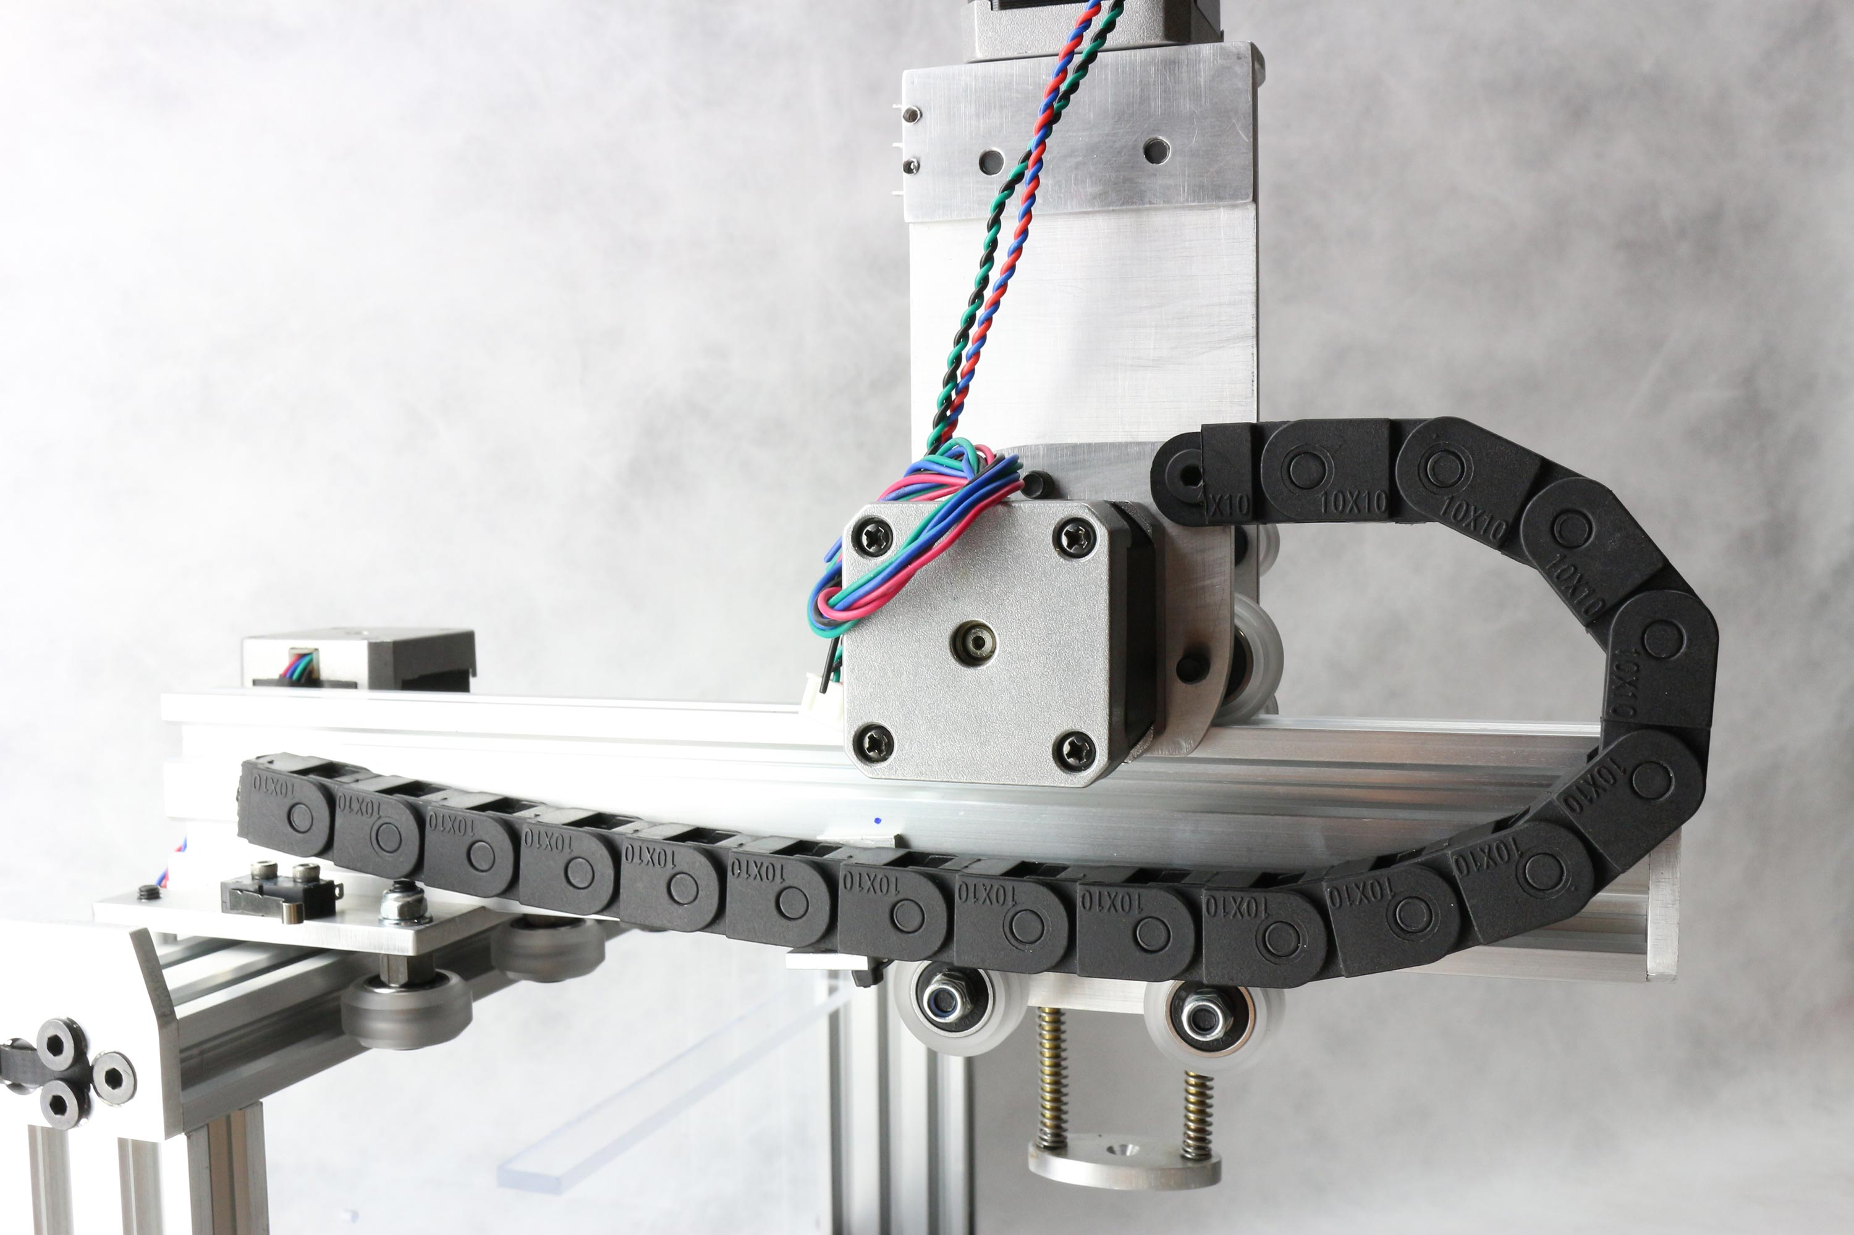

y-cable carrier mounted

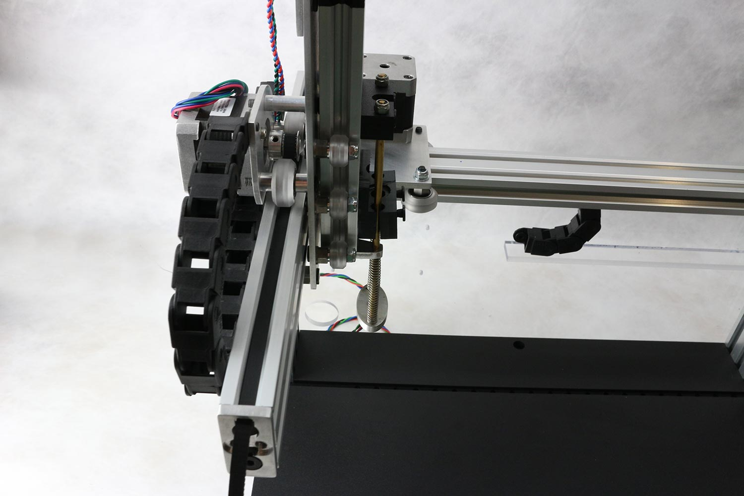

Y-belt detail

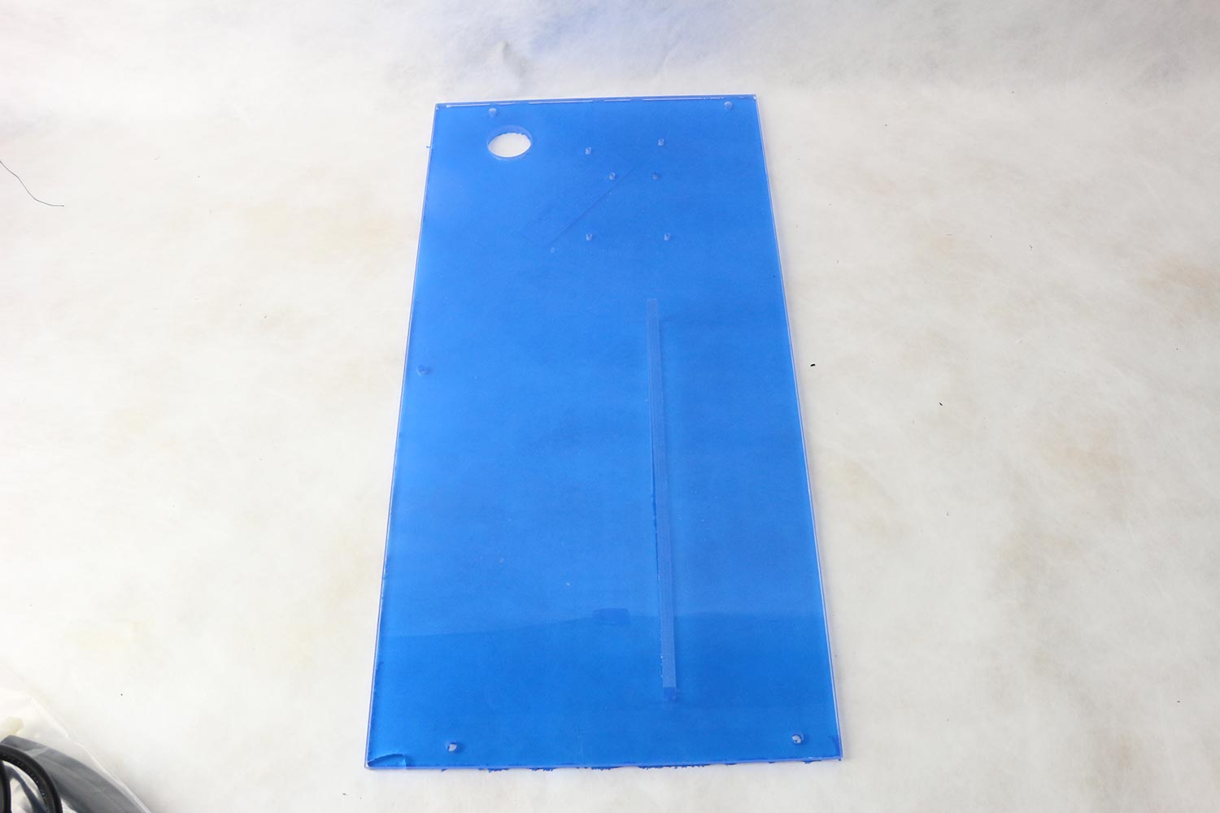

Back plate to mount electronics and x-cable-carrier.

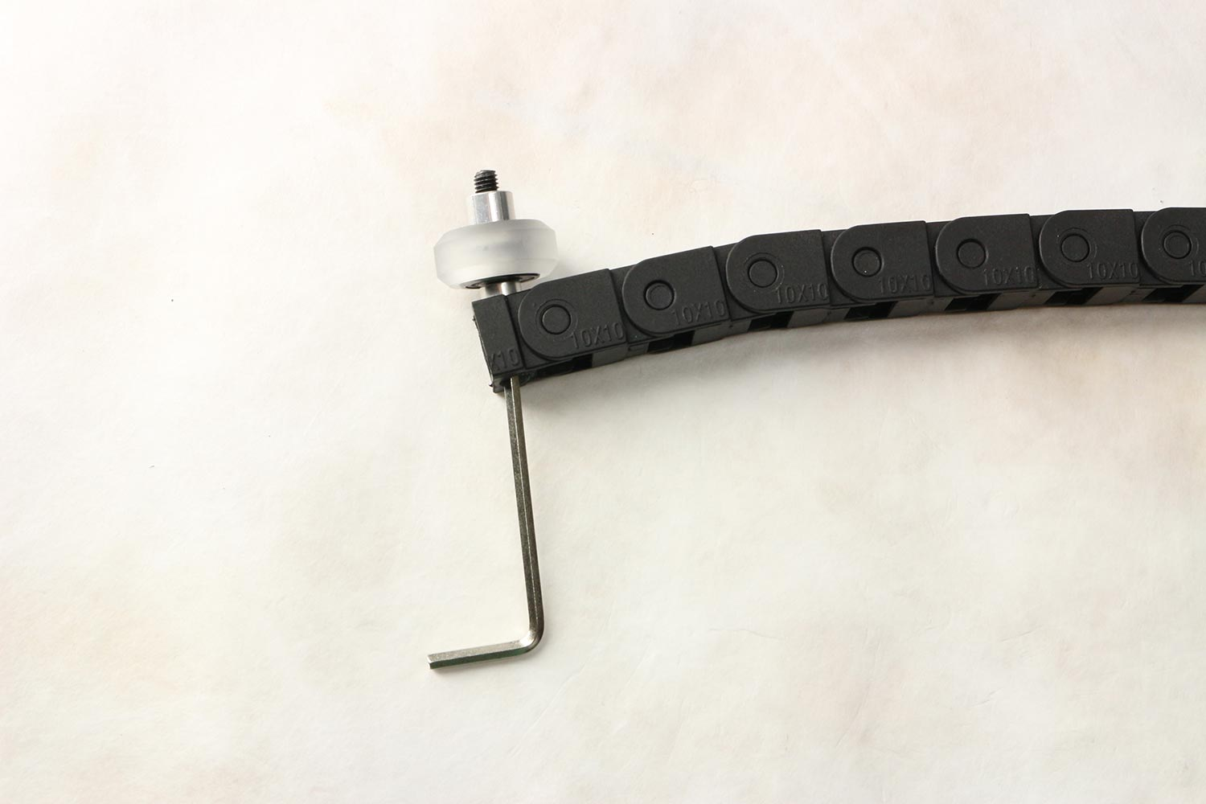

X-cable carrier is attached to x-carrier with final 6th wheel and extra spacer

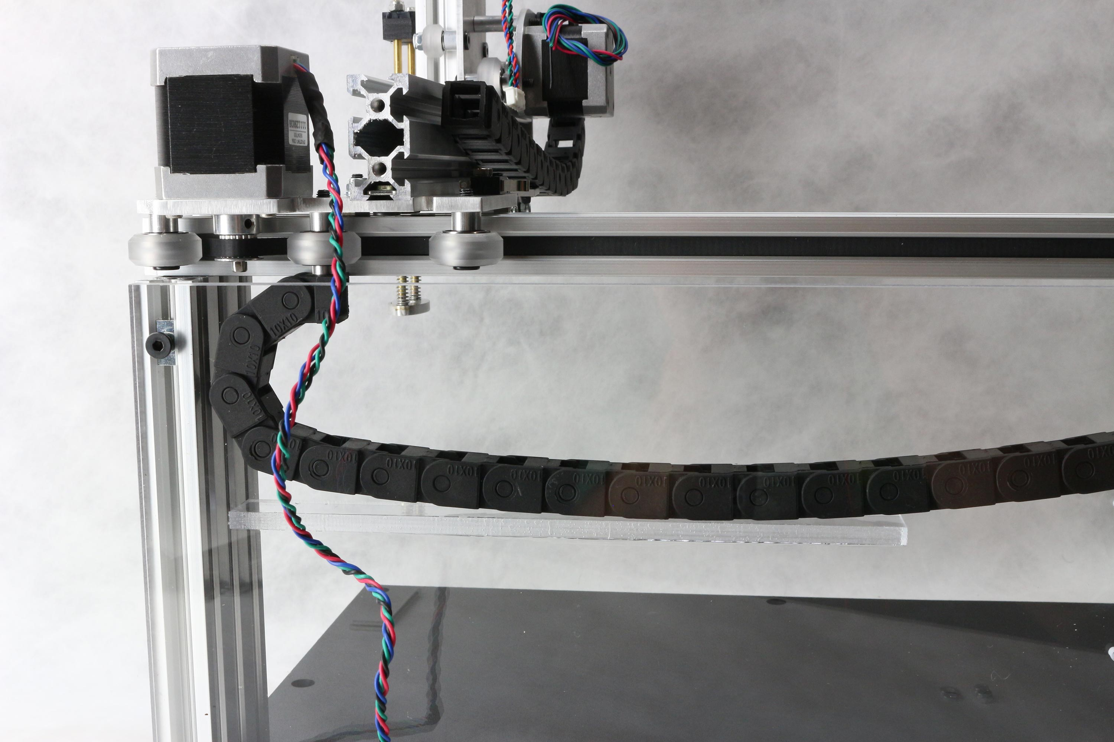

X-cable carrier is attached to x-carrier with final 6th wheel and extra spacer

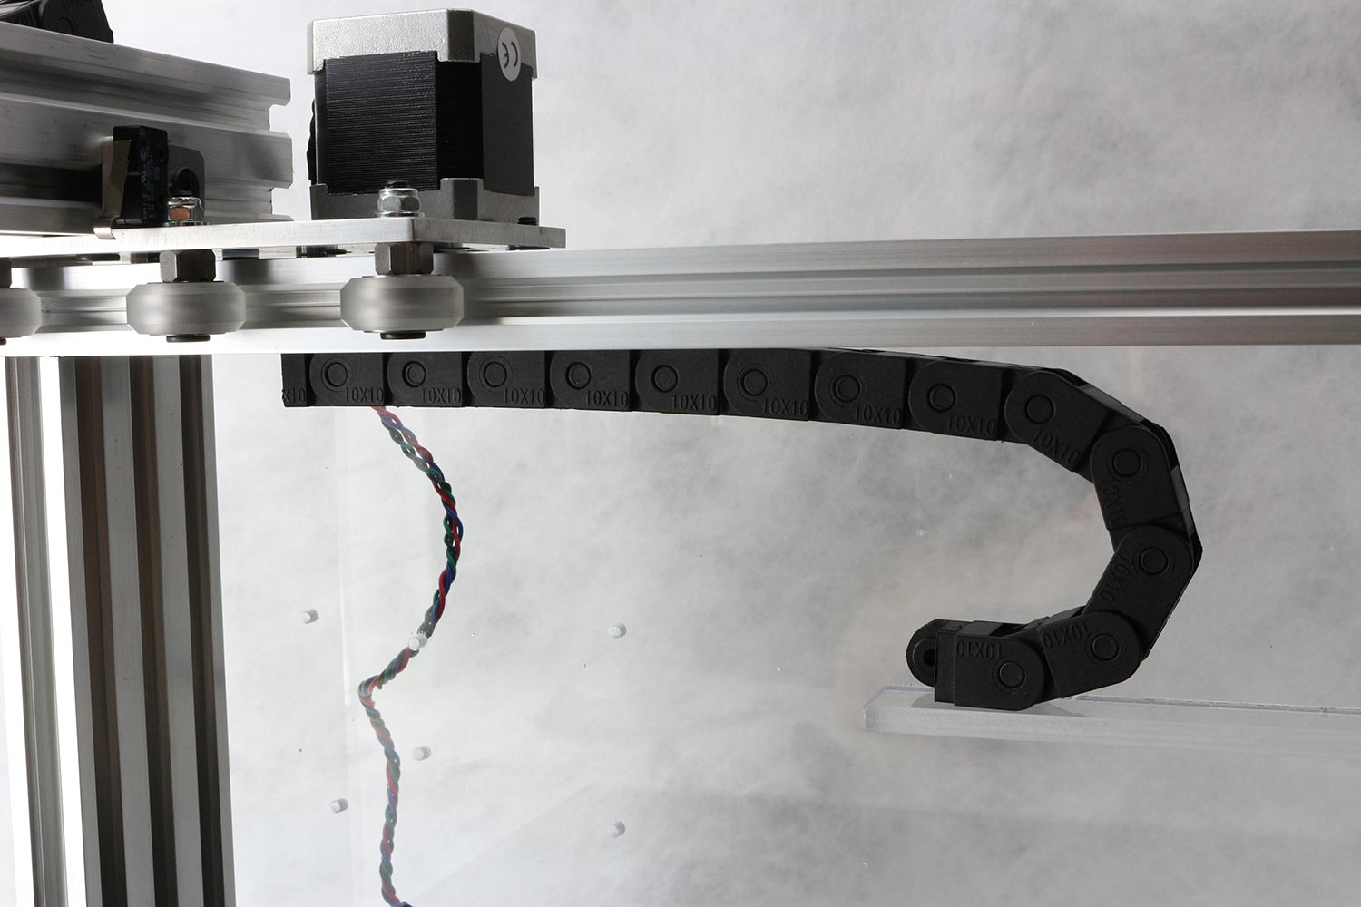

Front view of X-cable carrier, now also attached to backplate

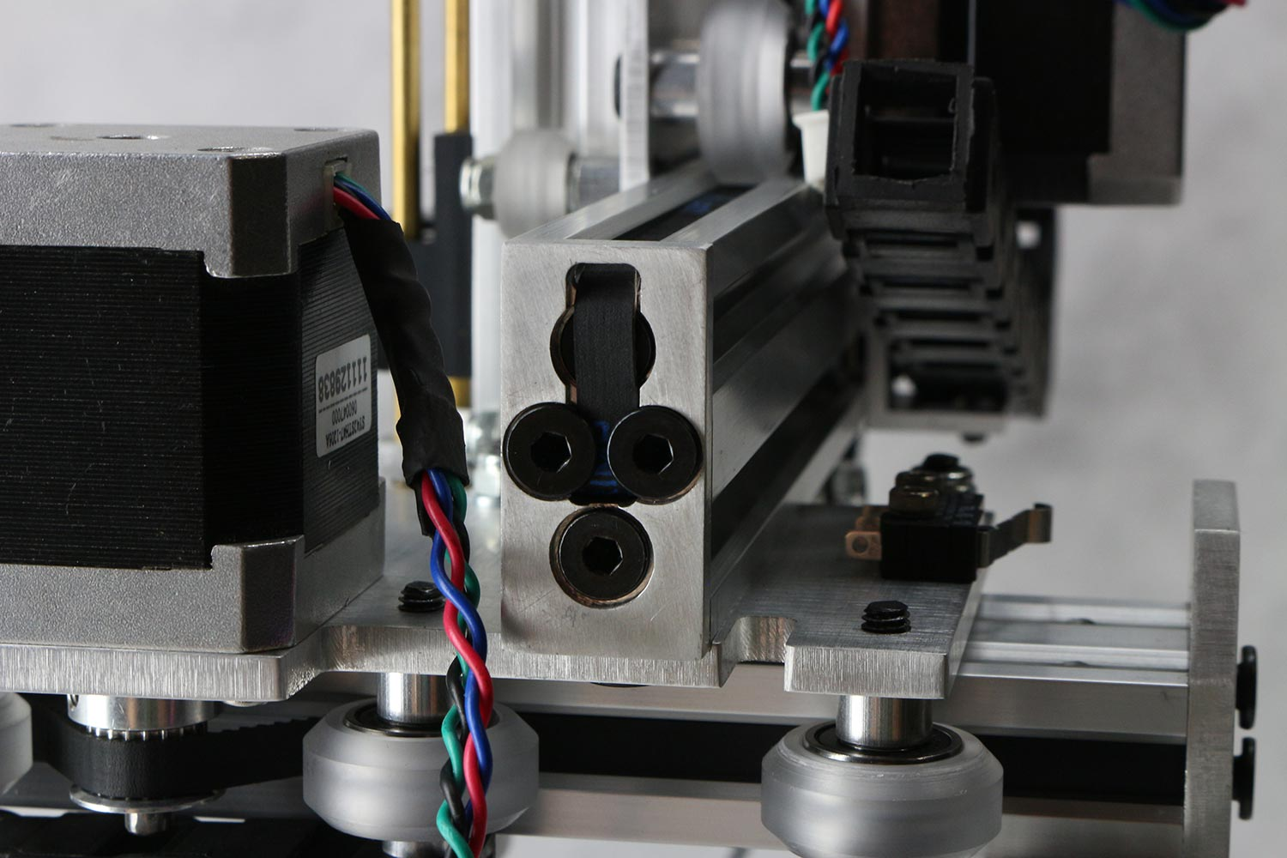

Final belts details (view from rear of x-cart)

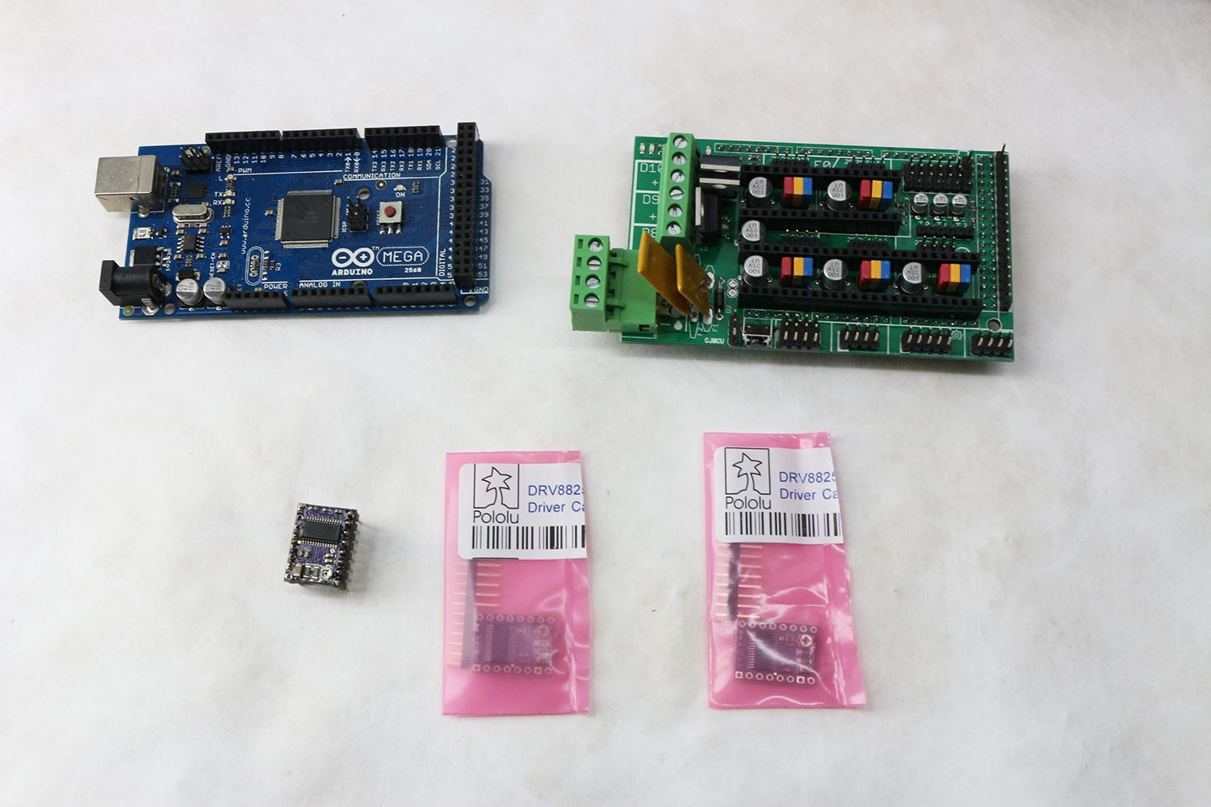

Electronics: Arduino Mega 2560, RAMPS 1.4, Pololu DRV8825 stepper drivers.

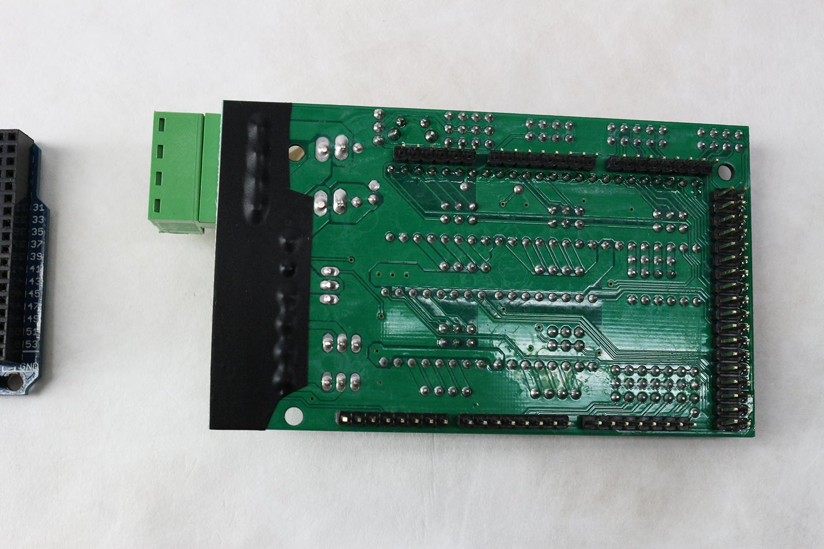

Bottom of RAMPS 1.4 board grinded down and electrically insulated.

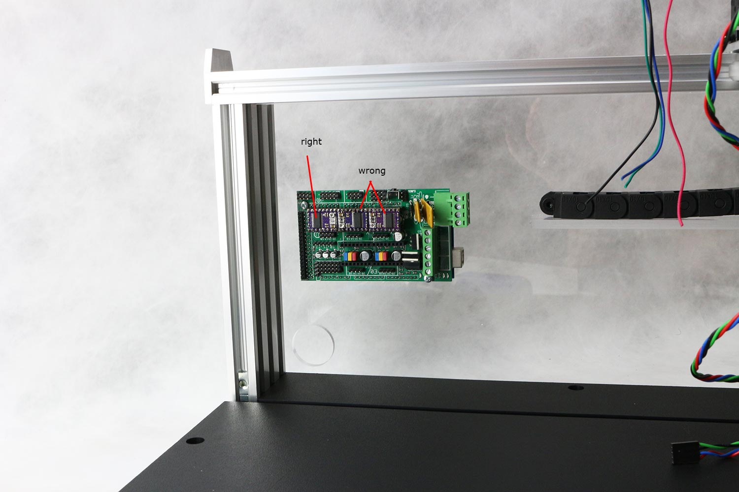

Arduino, RAMPS and stepper drivers assembled and mounted on backplate.

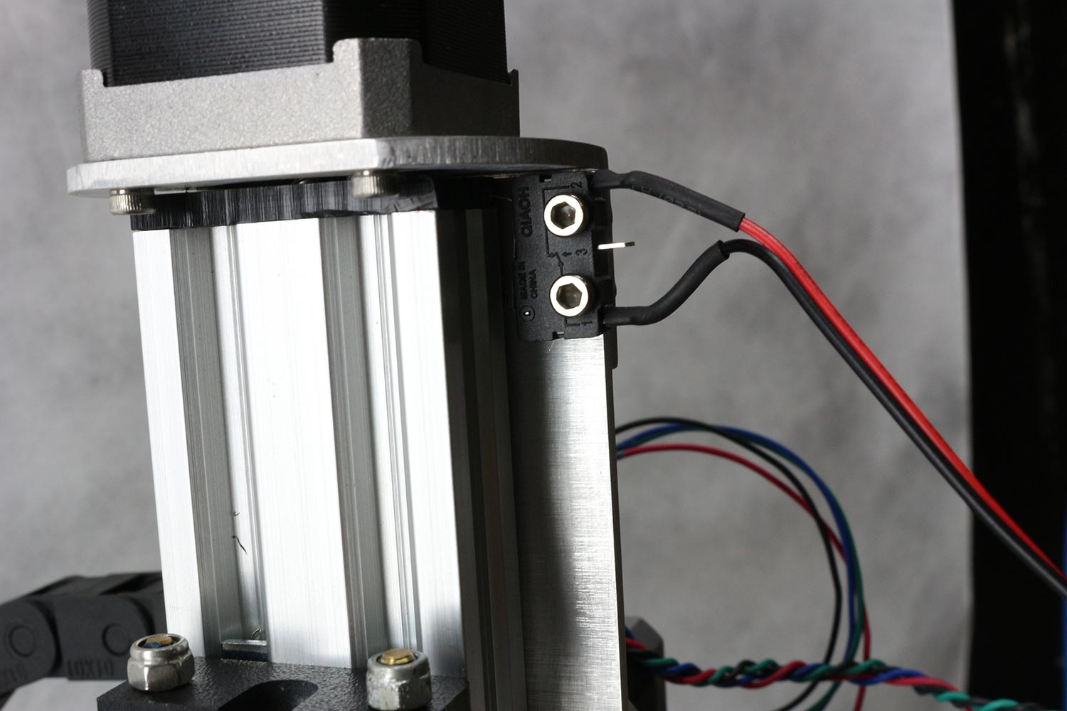

Connection of endstops

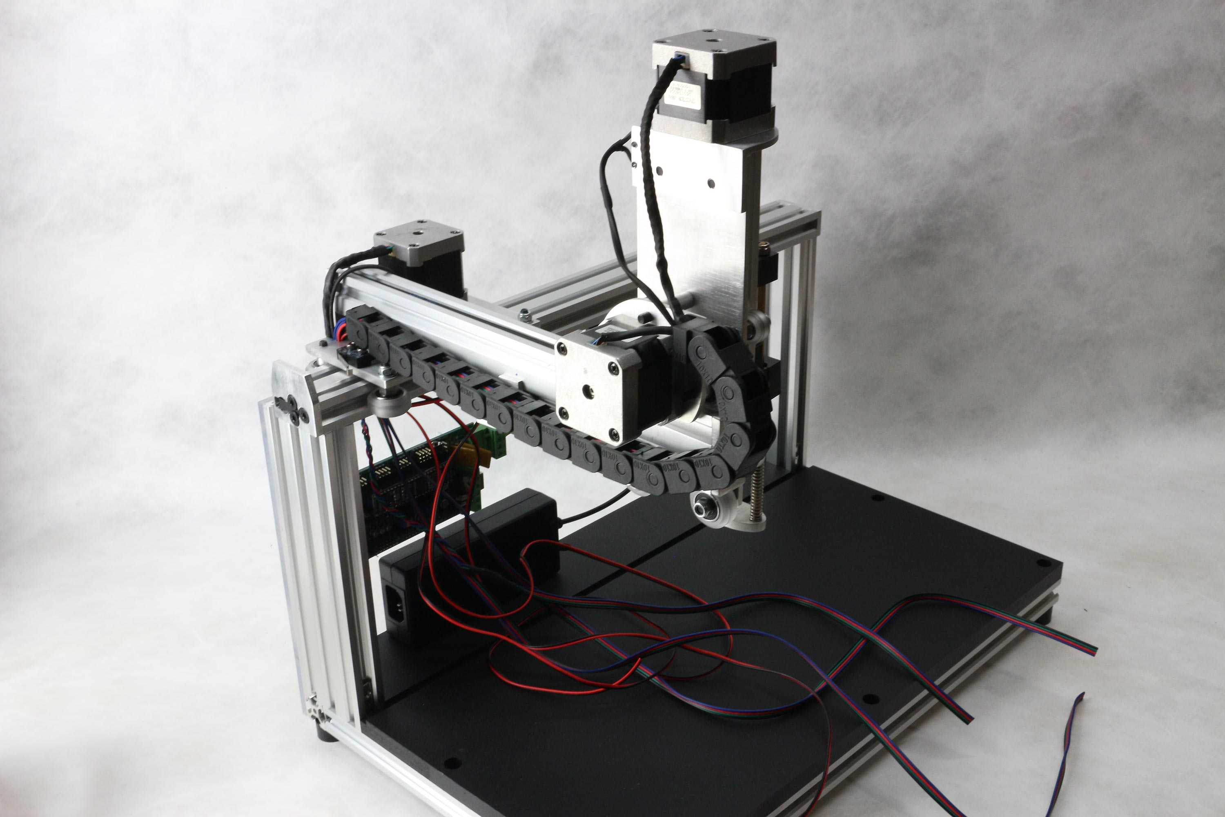

Stepper motor and endstop wires are routed through y-cable-carrier

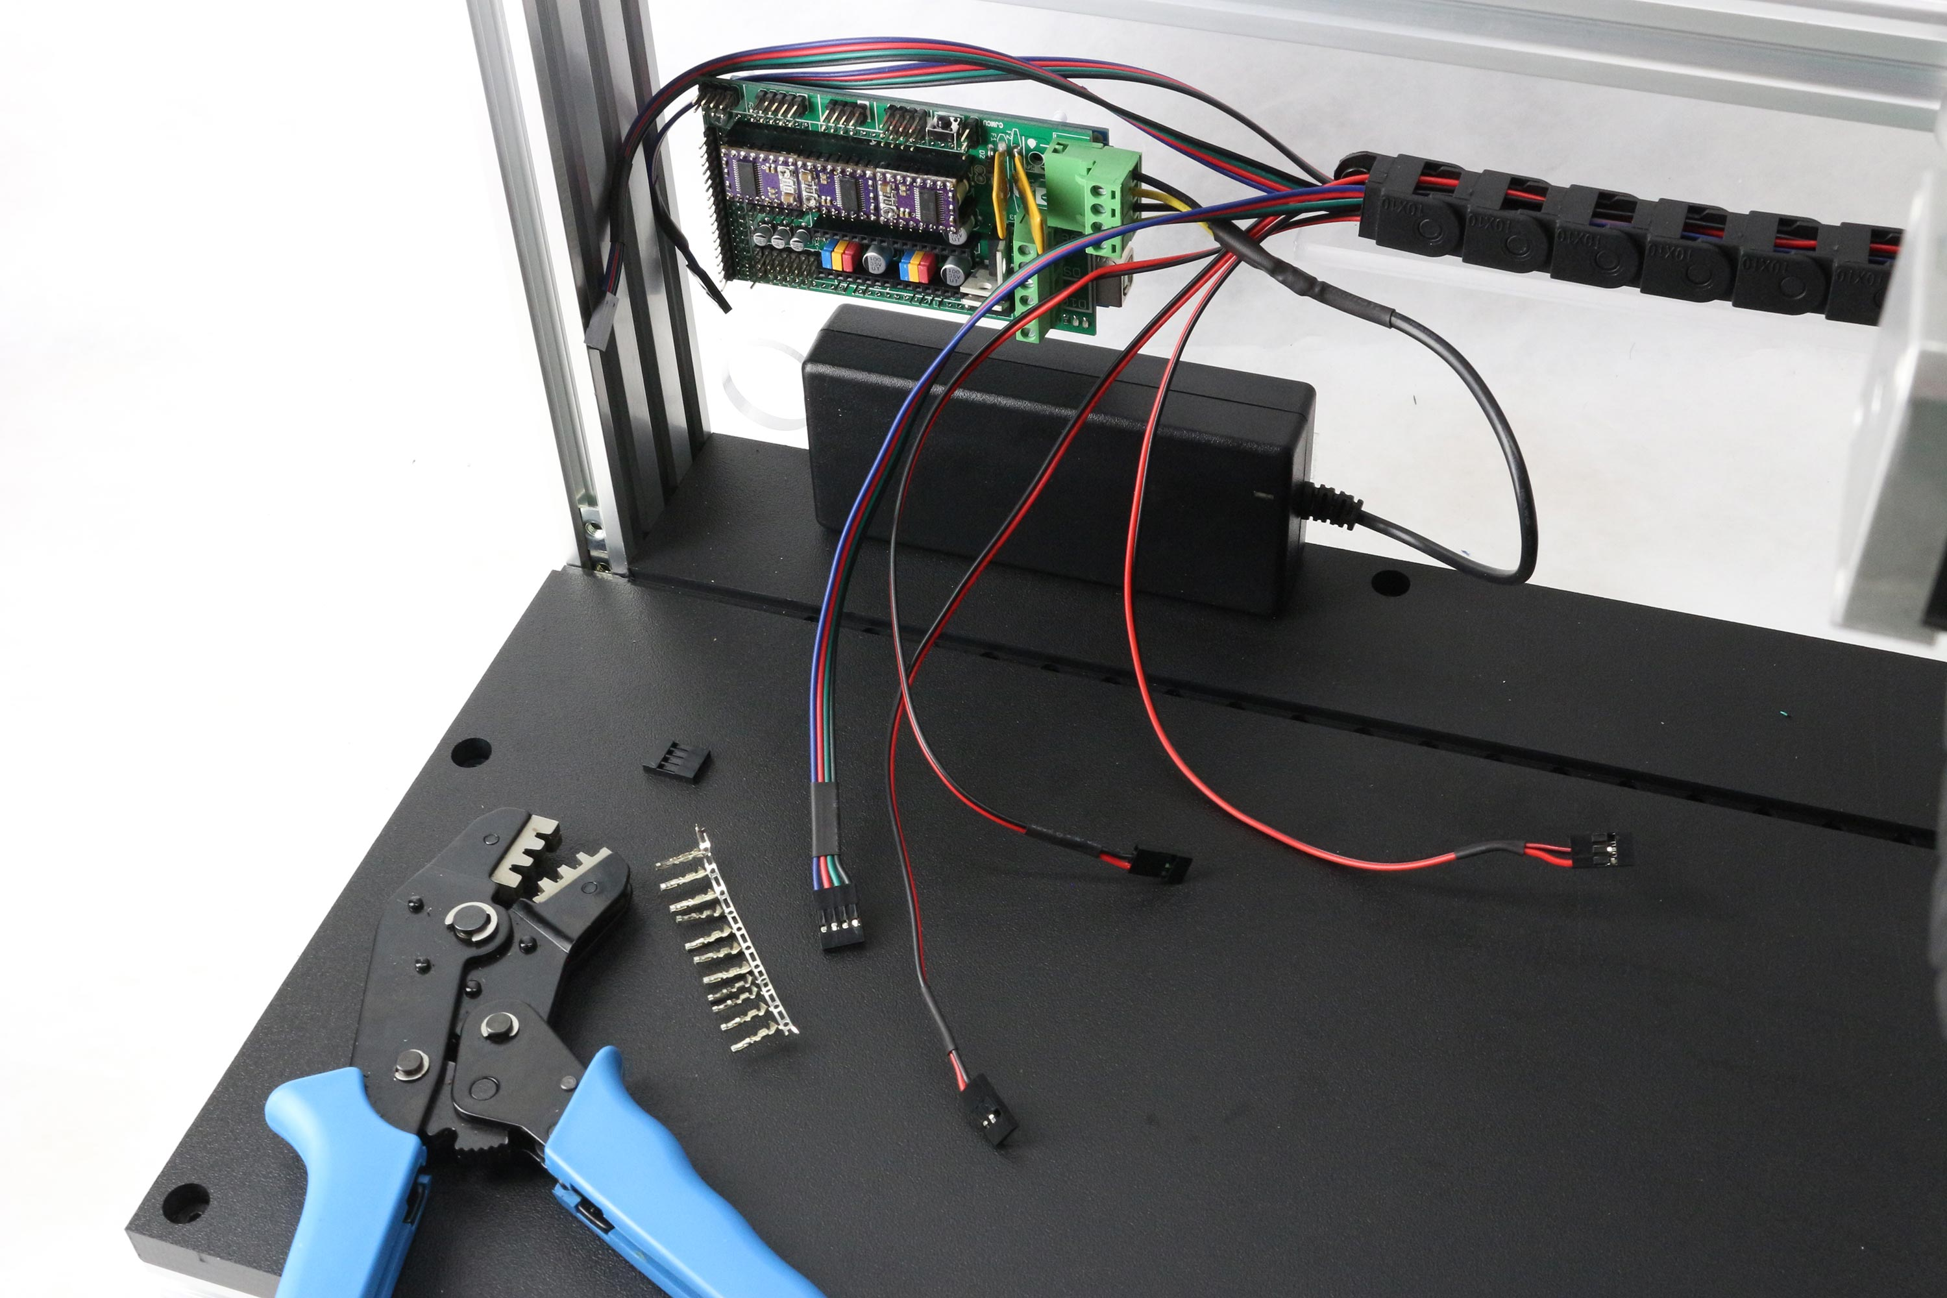

Stepper motor and endstop wires are routed through x-cable-carrier and connectors attached.

TO BE ADDED:

Solenoid hookup to RAMPS board

Front plate

Trays

Needle mount

Flowpath

Final